

Luxor University
Faculty of Computers & Information

ــــــــــــــــــــــــــــــــــــــــــــــــــــــــــــــــــــــــــــــــــــــــــــــــــــــــــــــــــــــــــــــــــــــــــــــــــــــــــــــــــــــــــــــــــــــــــــــــــــــــــــــــــــــ



Agri-Pro

Agricultural Investment, Market and Management System

UNDER SUPERVISION
Dr. Bassem Abdelatty Eldeeb Eng. Abdelrahim Alsadiq

SUBMITTED BY
- Ali Mohsen - Maram Mahmoud
- Abo Elfadl Ramadan - Mayar Mohamed
- Mohamed Salah - Fatma Hassan

2026

ABSTRACT

The Agricultural Investment and Management Platform is a web-based digital solution designed to address critical inefficiencies in Egypt’s agricultural sector, including fragmented investment workflows, limited operational transparency, and suboptimal communication between farmers, investors, and buyers. The platform provides a robust and structured environment to facilitate organized agricultural investment, comprehensive farm management, and direct market connectivity.

The system is composed of three core modules. The Investment System allows farmers to present their projects and enables investors to fund them in a fully transparent and accountable manner, supporting informed decision-making. The Management System delivers end-to-end project and farm management capabilities, including task and expenditure tracking, documentation management, real-time monitoring, smart contract execution, productivity and weather analysis, and profit allocation. The Agricultural Marketplace establishes a direct channel for farmers to showcase and sell their products post-harvest, minimizing reliance on intermediaries and enhancing market efficiency.

Primary stakeholders include farmers, investors, and buyers, while secondary stakeholders such as governmental bodies, agricultural institutions, and domain experts benefit from verified data and analytical insights. The system boundaries exclude online payment processing, logistics, and fully automated farming operations. Implemented with React.js for the front-end and Node.js with Express.js for the back-end, the platform represents a significant advancement in structuring agricultural investment and promoting sustainable agricultural development in Egypt.

TABLE OF CONTENTS
ABSTRACT II
TABLE OF CONTENTS III
CHAPTER 1 SYSTEM OVERVIEW 1

1.1 | MOTIVATION | 2
1.2 | PROBLEM STATEMENT | 2
1.3 | OVERVIEW | 2
1.4 | OBJECTIVES AND SCOPE | 2
1.5 | TARGET AUDIENCE AND EXPECTED IMPACT | 2
CHAPTER | 2 RELATED WORKS | 3
2.1 | EXISTING SYSTEMS | 4
2.2 | COMPARISON & LIMITATIONS | 4
2.3 | JUSTIFICATION FOR THE PROPOSED SYSTEM | 4
CHAPTER | 3 SYSTEM REQUIREMENTS & TECHNIQUE | 5
3.1 | SYSTEM REQUIREMENTS | 6
3.1.1 | FUNCTIONAL REQUIREMENTS | 6
3.1.2 | NON-FUNCTIONAL REQUIREMENTS | 6
3.2 | TECHNIQUES AND TOOLS | 6
CHAPTER | 4 PROPOSED SYSTEM & METHODOLOGY | 7
4.1 | SYSTEM USE CASE DIAGRAM | 8
4.2 | USE CASE DESCRIPTION (USE CASE SCENARIO) | 8
4.3 | SYSTEM ARCHITECTURE | 8
4.4 | DATAFLOW DIAGRAMS | 8
4.4.1 | CONTEXT DIAGRAM (LEVEL 0) | 8
4.4.2 | DATAFLOW DIAGRAM (LEVEL 1) | 8
4.5 | ACTIVITY DIAGRAM | 8
4.6 | SEQUENCE DIAGRAMS | 8
4.7 | ER DIAGRAM | 8
CHAPTER | 5 CONCLUSIONS & FUTURE WORK | 9
5.1 | CONCLUSIONS | 10
5.2 | FUTURE WORK | 10
5.3 | REFERENCES | 10

CHAPTER 1

SYSTEM OVERVIEW
  - MOTIVATION
The agricultural sector is one of the most fundamental pillars of the Egyptian economy, contributing significantly to national income and employing a large portion of the workforce, particularly in rural areas. Agriculture plays a vital role in ensuring food security, supporting rural livelihoods, and sustaining economic stability across the country.
Despite its strategic importance, agricultural investment in Egypt remains weak, fragmented, and largely unstructured, with limited adoption of digital technologies. Current agricultural investments are significantly lower than the sector’s actual potential, while market projections indicate substantial growth opportunities in the coming years. The agricultural market in Africa and the Middle East is expected to exceed $1 trillion by 2030, highlighting the scale of opportunity available to Egypt as a key agricultural player in the region.
This situation reveals a considerable investment gap within the Egyptian agricultural sector, driven not by a lack of resources, but by insufficient data availability, limited transparency, and weak connectivity between farmers and investors. These challenges restrict farmers’ ability to manage their operations professionally and discourage investors from participating in agricultural projects due to high uncertainty and perceived risks.
The motivation behind this project is to establish a technology-driven agricultural investment platform tailored to the Egyptian context, built on accurate data, transparency, and digital management tools. The platform aims to empower Egyptian farmers to document and manage their agricultural activities professionally, while providing investors with secure, data-backed, and reliable investment opportunities. Ultimately, the project seeks to enhance agricultural productivity, attract sustainable investments, and contribute to the modernization and growth of Egypt’s agricultural sector.

  - PROBLEM STATEMENT
) Current Situation (
Agricultural investment currently relies on informal communication and non-standard documentation. There is no unified platform that connects farmers, investors, and buyers in a structured way. Project evaluation, monitoring, and financial settlement are mostly manual and inefficient. Additionally, farmers struggle to reach buyers directly after harvesting their crops, forcing them to depend on intermediaries.
Farmer Challenges
Arab farmers face numerous challenges, including:
- Absence of digital documentation for their agricultural data and crops
- Difficulty accessing financial support or reliable investors
- Weak marketing capabilities and limited communication with markets or funding entities
- No mechanism to prove credibility or demonstrate farming progress
- Limited tools for transparent reporting and risk management
- Inability to showcase products professionally to attract direct buyers
- Difficulty presenting projects professionally to attract investors

Investor Challenges
Investors encounter significant obstacles such as:
- Lack of accurate information about land quality and crop potential
- Absence of transparency regarding expected returns and risks
- No trusted platform to facilitate the evaluation of agricultural projects
- Inability to track project progress or detect early risks in real-time
- High uncertainty due to missing data, leading to mistrust and withdrawal from agricultural investments
- Lack of verified information about farmers and project feasibility

Buyer and Market Challenges
- No specialized Arab platform that enables farmers to showcase their products easily
- Absence of direct communication channels between farmers and potential buyers
- Dependence on middlemen, which increases costs and decreases farmer profits
- Difficulty accessing fresh, locally sourced agricultural products directly from farmers at fair prices
Operational and Systemic Challenges
- No digital framework to document agreements or manage smart contracts
- Weak oversight increases the chances of fraud, mismanagement, or communication gaps
- Manual financial settlements result in delays and errors
- Lack of standardized processes across the agricultural investment lifecycle
This gap between farmers, investors, and buyers represents a major barrier to the growth of the agricultural sector, despite its enormous potential. The proposed project aims to bridge this divide through an integrated digital platform that provides accurate data, intelligent analytics, and direct market access, making agricultural investment safer, more effective, and more profitable.

  - OVERVIEW
The Agricultural Investment and Management Platform is a comprehensive digital ecosystem designed to revolutionize the Egyptian agricultural sector by connecting three critical stakeholders—farmers, investors, and buyers—through an integrated suite of three interconnected systems:
System Architecture
The platform comprises three main systems that work together seamlessly:
1. Investment System
An intelligent agricultural investment platform designed to connect farmers with investors in a transparent and organized environment. Farmers register detailed information about their land, including crop types, acreage, production quantities, costs, and planting and harvesting schedules. Investors can browse available agricultural projects through the platform, review their detailed data, and start the investment plan.
2. Management System
An integrated digital system that streamlines the full agricultural investment lifecycle, starting from user registration and project submission, through funding, execution, monitoring, and ending with harvest evaluation and profit distribution. The platform acts as a trusted intermediary that:
- Verifies users and validates their credentials
- Publishes and manages agricultural projects
- Manages smart investment contracts with automated execution
- Provides real-time project monitoring tools and dashboards
- Offers clear financial projections and automated reporting
- Implements structured risk-handling mechanisms
The system ensures transparency through continuous progress tracking, electronic documentation, and automated financial settlement. After project completion, it supports evaluation, feedback, and reinvestment, creating a continuous loop that sustains long-term agricultural growth and recurring investment.

3. Agricultural Marketplace
A digital marketplace that allows farmers to list their crops after harvesting, displaying detailed information such as:
- Crop type and variety
- Available quantity
- Quality grade and certification
- Expected price range
- Real photos and descriptions of the products
Buyers (wholesalers, retailers, food factories, supermarkets, and individual consumers) can browse the available products and directly contact farmers through the platform to negotiate or finalize deals. The platform facilitates product showcasing and direct communication between farmers and buyers but does not handle payments, logistics, shipping, or storage.
Core Technologies
The platform is equipped with advanced technological capabilities:
Smart Contract System that:
- Automates agreement execution between parties
- Ensures transparent profit-sharing mechanisms
- Reduces disputes through clear, predefined terms
- Facilitates automated financial settlements

Real-Time Monitoring Tools that:
- Track project progress throughout the agricultural cycle
- Provide weekly updates and performance reports
- Alert stakeholders to potential risks or deviations
- Enable data-driven interventions when needed
System Integration
The three systems work together to create a complete agricultural value chain:
- Farmers use the Management System to document their operations and attract funding
- Investors use the Investment System to fund promising agricultural projects
- After harvest, farmers use the Marketplace to sell their products directly
- Profits are distributed through the Management System based on smart contracts
- The cycle repeats, building trust and enabling reinvestment
The ultimate goal is to transform agriculture across the Arab world into an organized digital sector built on trust, transparency, data-driven decision-making, and direct market access.

  - OBJECTIVES AND SCOPE
Core Objectives
The platform aims to achieve the following strategic objectives:
- Build an Egyptian digital platform that connects farmers with investors and buyers through a transparent and secure ecosystem
- Enable farmers to manage their agricultural data easily and accurately, including crops, costs, performance metrics, and risks
- Provide a comprehensive and reliable database of land, crops, productivity metrics, and regional agricultural trends
- Help investors make informed decisions using real-time data, analytics, and verified reports
- Support the transition to smart and sustainable agriculture across the Egyptian world through digital tools and best practices
- Ensure transparency across all stages: project creation → funding → execution → monitoring → harvest → profit distribution → reinvestment
- Enable direct market access for farmers to sell their products without intermediaries
- Create a trusted marketplace where buyers can access fresh, locally sourced agricultural products at fair prices

System Scope
In-Scope Features
For the Investment System:
- Investor Dashboard for browsing projects, analyzing ROI and risks, and tracking investments
- AI Investment Recommendation Engine that suggests best opportunities based on project data and market trends
- Financial Analysis Module showing costs, revenue projections, and performance metrics
- Investment Reporting that generates accurate reports for investors, farmers, and authorities
For the Management System:
- Farmer Dashboard for managing crops, costs, schedules, and monitoring performance
- Smart Contracts that define profit-sharing, responsibilities, and loss allocation between farmer and investor
- Real-time project monitoring and progress tracking
- Automated financial settlement and profit distribution
- Electronic documentation and audit trails
- User verification and validation system
- Risk assessment and alert mechanisms
For the Agricultural Marketplace:
- Product listing and showcasing capabilities for farmers
- Search and filtering tools for buyers to find specific products
- Direct communication channel between farmers and buyers
- Product information management (photos, descriptions, quantities, prices)

Platform-Wide Features:
- Centralized Reporting System providing accurate data for government entities and economic institutions
- Data analytics and trend analysis
- User authentication and role-based access control
- Multi-user support with different roles (Farmer, Investor, Buyer, Admin)

Out-of-Scope Features
The following features are explicitly excluded from the current system scope:
- Direct online payments or banking integration (handled externally)
- Legal contracts outside the platform (platform provides templates only)
- Mobile application (web platform only in initial release)
- Automated farming operations such as irrigation control, fertilization systems, or machinery automation
- Integration with stock markets or trading platforms
- Logistics and delivery services for the marketplace
- Product storage or warehousing facilities
- Payment processing for marketplace transactions
- Insurance services for crops or investments
- Weather monitoring systems (may integrate with external APIs in future releases)

  - TARGET AUDIENCE AND EXPECTED IMPACT

Target Audience

The platform is designed to serve multiple stakeholder groups across the agricultural value chain:
Primary Users:

1. Farmers
- Small to medium-scale farmers seeking funding and tools to document their agricultural operations
- Large-scale agricultural enterprises looking to attract investment and expand operations
- Young farmers interested in adopting digital agricultural practices
- Traditional farmers transitioning to modern, data-driven farming methods
2. Investors
- Individual investors looking for safe, profitable, and data-driven agricultural investment opportunities
- Agricultural investment firms seeking to diversify their portfolios
- Impact investors interested in supporting sustainable agriculture and food security
- Angel investors and venture capitalists exploring agri-tech opportunities
- Institutional investors seeking long-term agricultural investments
3. Buyers
- Wholesalers and distributors seeking bulk agricultural products
- Retailers and supermarket chains looking for fresh, local produce
- Food processing factories requiring raw agricultural materials
- Restaurants and hospitality businesses seeking quality ingredients
- Individual consumers interested in buying directly from farmers
- Export companies looking for agricultural products from the region

Secondary Users:

4. Government Agencies
- Ministries of Agriculture working to advance digital agriculture initiatives
- Economic development agencies supporting agricultural sector growth
- Food security organizations monitoring agricultural production
- Rural development departments promoting farmer welfare
5. Economic and Agricultural Institutions
- Agricultural research centers analyzing national and regional trends
- Economic development organizations supporting sector transformation
- Agricultural cooperatives and unions representing farmer interests
- Financial institutions developing agricultural lending programs

6. Agricultural Experts and Consultants
- Agronomists supporting monitoring and reporting
- Agricultural engineers providing technical guidance
- Financial advisors specializing in agricultural investments
- Technology consultants helping farmers adopt digital tools

Expected Impact

Economic Impact:
- Mobilize billions in previously untapped agricultural investment capital
- Increase farmer income through better financing and direct market access
- Reduce transaction costs by eliminating intermediaries
- Create new job opportunities in agri-tech and digital agriculture
- Contribute to GDP growth through agricultural sector expansion
Social Impact:
- Empower farmers with digital tools and financial access
- Improve rural livelihoods and reduce urban migration
- Enhance food security through increased agricultural productivity
- Build trust between stakeholders through transparency
- Create a culture of data-driven decision-making in agriculture
Environmental Impact:
- Promote sustainable agricultural practices through better monitoring
- Reduce waste through efficient planning and direct sales channels
- Enable precision agriculture through data analytics
- Support climate-smart agriculture initiatives
Technological Impact:
- Accelerate digital transformation of the Arab agricultural sector
- Establish best practices for agri-tech platforms in the region
- Create a foundation for future innovations (IoT, blockchain, etc.)
- Build a comprehensive agricultural data repository for research and policy-making

CHAPTER 2

RELATED WORKS
2.1 EXISTING SYSTEMS
The agricultural technology landscape has witnessed significant growth in recent years, with various platforms attempting to address different aspects of agricultural challenges. This section analyzes existing solutions in three main categories: agricultural investment platforms, farm management systems, and agricultural marketplaces.
2.1.1 Agricultural Investment Platforms
FarmTogether (United States)
- Description: A crowdfunding platform that allows investors to invest in farmland across the United States
- Features: Fractional ownership of farmland, professional farm management, transparent reporting
- Target Market: Primarily U.S. investors and farmland
- Strengths: Established legal framework, professional management, detailed financial reporting
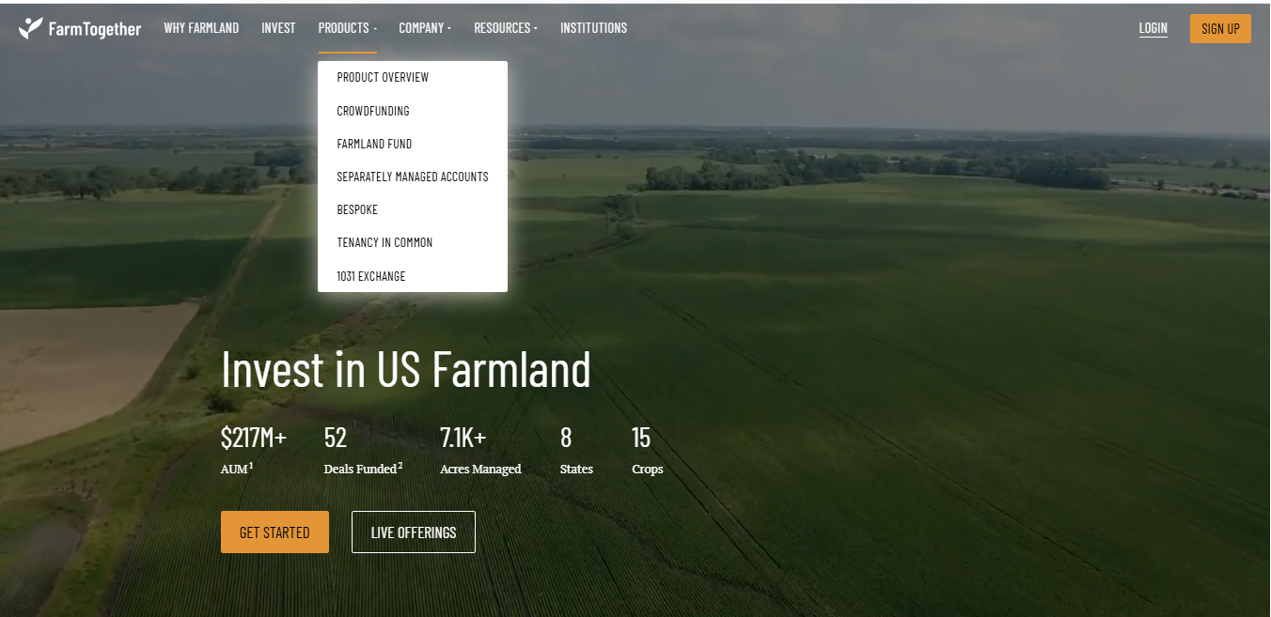
- Limitations: Limited to farmland ownership rather than crop-specific investments, no direct farmer participation, U.S.-focused with limited international reach

AcreTrader (United States)
- Description: An online farmland investing platform offering shares in agricultural properties
- Features: Due diligence reports, land management services, annual reporting
- Target Market: Accredited investors in the U.S.
- Strengths: Rigorous vetting process, professional farm operations
- Limitations: High minimum investment thresholds, focuses on land assets rather than operational farming, excludes small-scale farmers

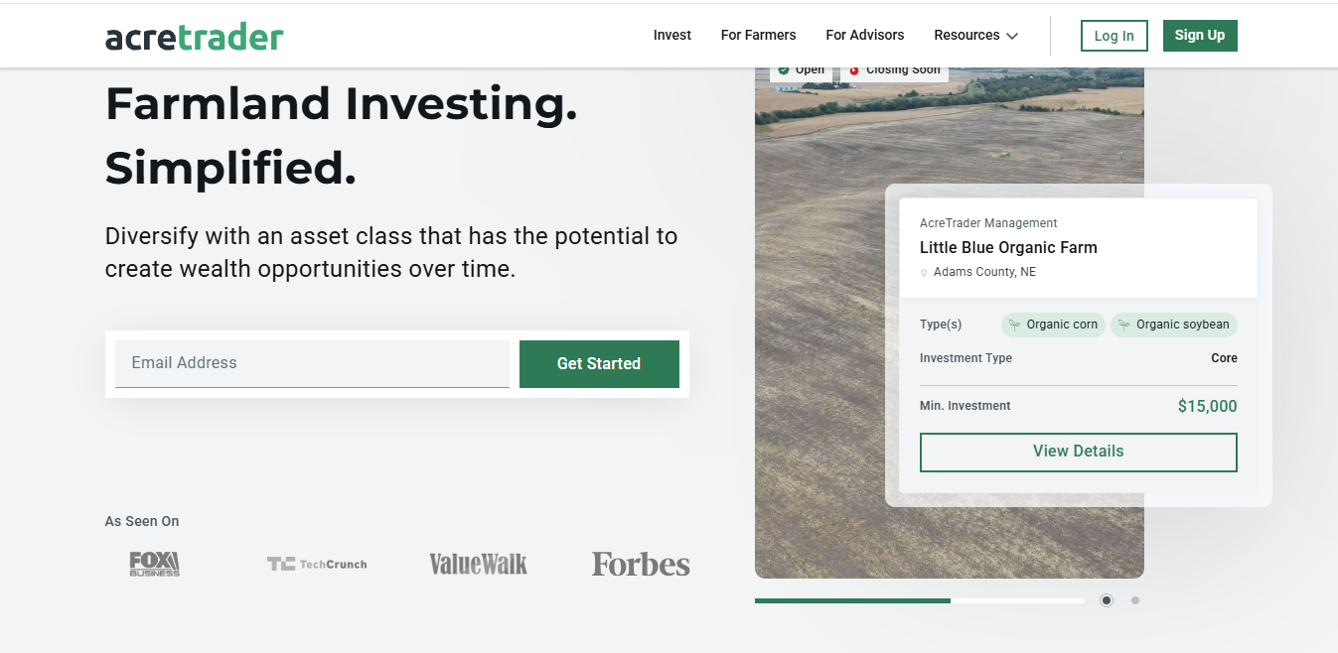

2.1.2 Farm Management Systems
Farmigo (Global)
- Description: A farm management software focusing on CSA (Community Supported Agriculture) operations
- Features: Customer management, delivery logistics, payment processing
- Target Market: Small to medium farms with direct-to-consumer sales
- Strengths: User-friendly interface, integrated payment systems
- Limitations: No investment management features, limited to specific farm business models, lacks AI-driven analytics

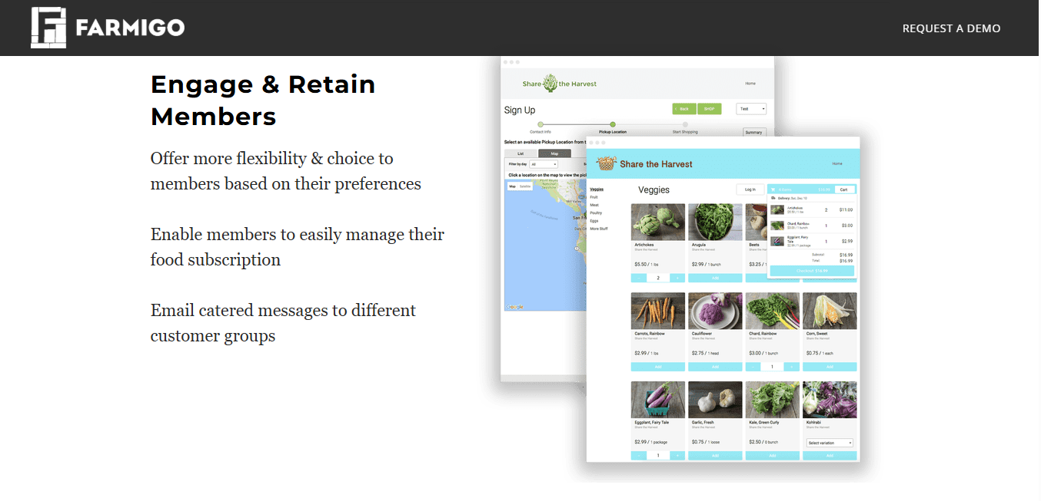

Cropio (Global)
- Description: A satellite-based farm management system using remote sensing technology
- Features: Field monitoring, vegetation indices, weather forecasting, scouting
- Target Market: Large-scale agricultural operations
- Strengths: Advanced satellite technology, precision agriculture tools
- Limitations: High costs, complexity unsuitable for small farmers, no financial or investment management

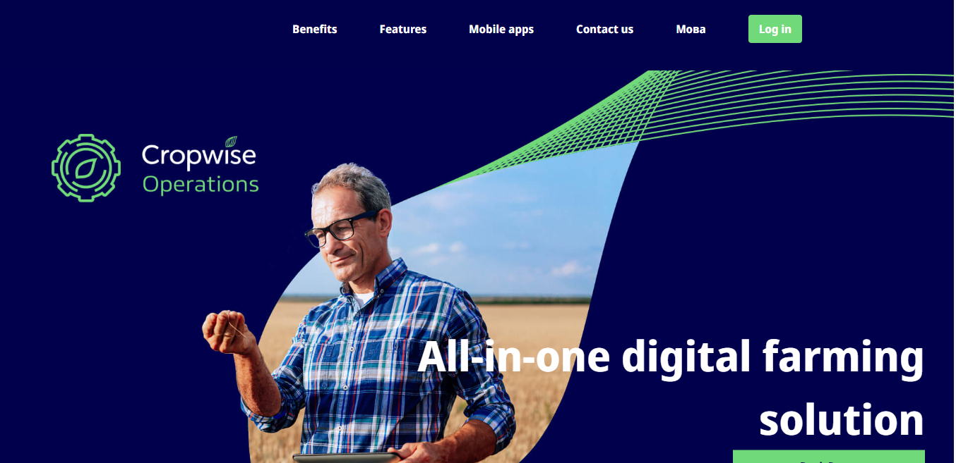

2.1.3 Agricultural Marketplaces
Farmers Business Network (FBN) (United States)
- Description: A digital platform providing market data, input purchasing, and grain marketing
- Features: Price transparency, bulk purchasing, market analytics
- Target Market: U.S. farmers
- Strengths: Strong network effects, transparent pricing, farmer-focused
- Limitations: Limited to input supplies and grain marketing, no fresh produce marketplace, U.S.-centric

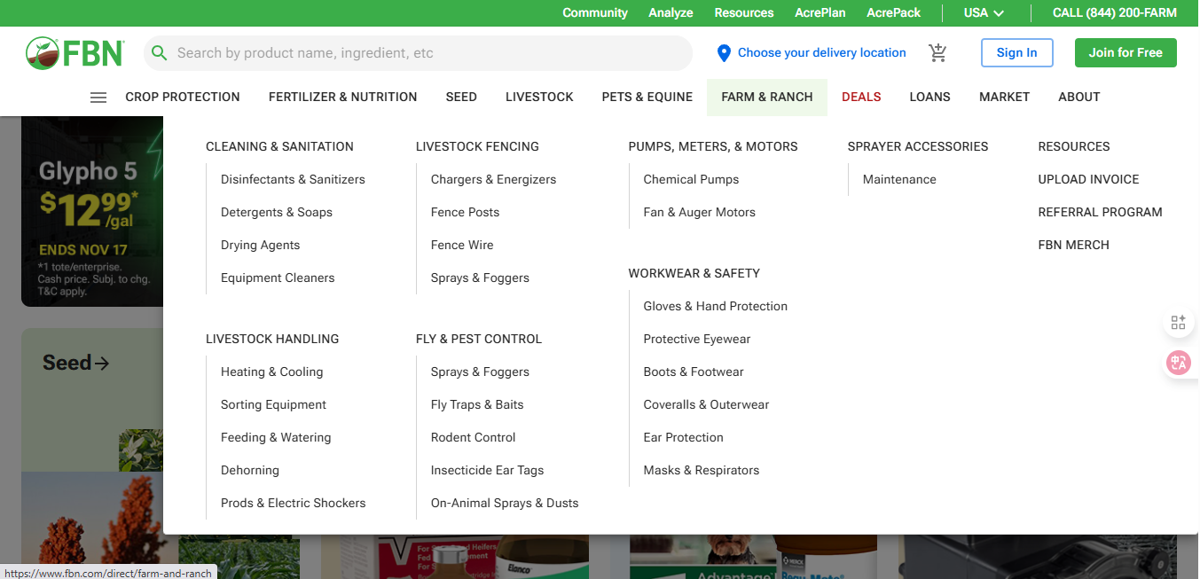

Ninjacart (India)
- Description: A B2B agricultural marketplace connecting farmers with retailers
- Features: Supply chain management, quality control, logistics coordination
- Target Market: Indian farmers and retailers
- Strengths: End-to-end logistics, quality assurance, large scale operations
- Limitations: Heavy involvement in operations (not just a platform), requires significant infrastructure, limited transparency for end buyers

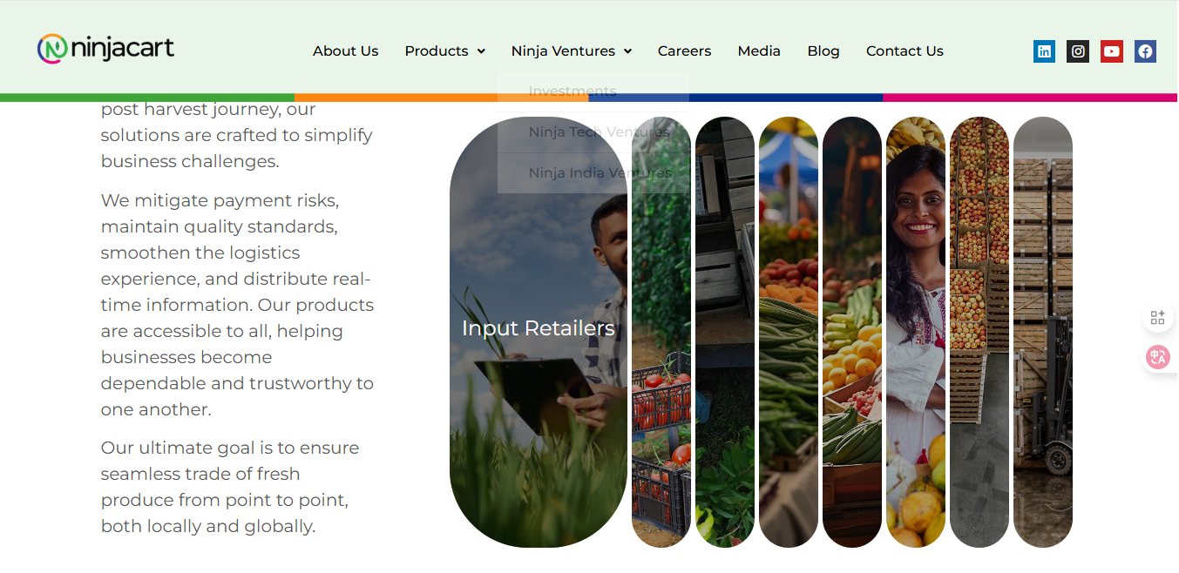

2.1.4 Regional Arab Platforms
Mazra3ti (Egypt)
- Description: An agricultural e-commerce platform for selling agricultural products
- Features: Online ordering, delivery services
- Target Market: Egyptian consumers and farmers
- Strengths: Local market understanding, Arabic interface
- Limitations: Traditional e-commerce model, no investment component, limited to specific regions, basic technology

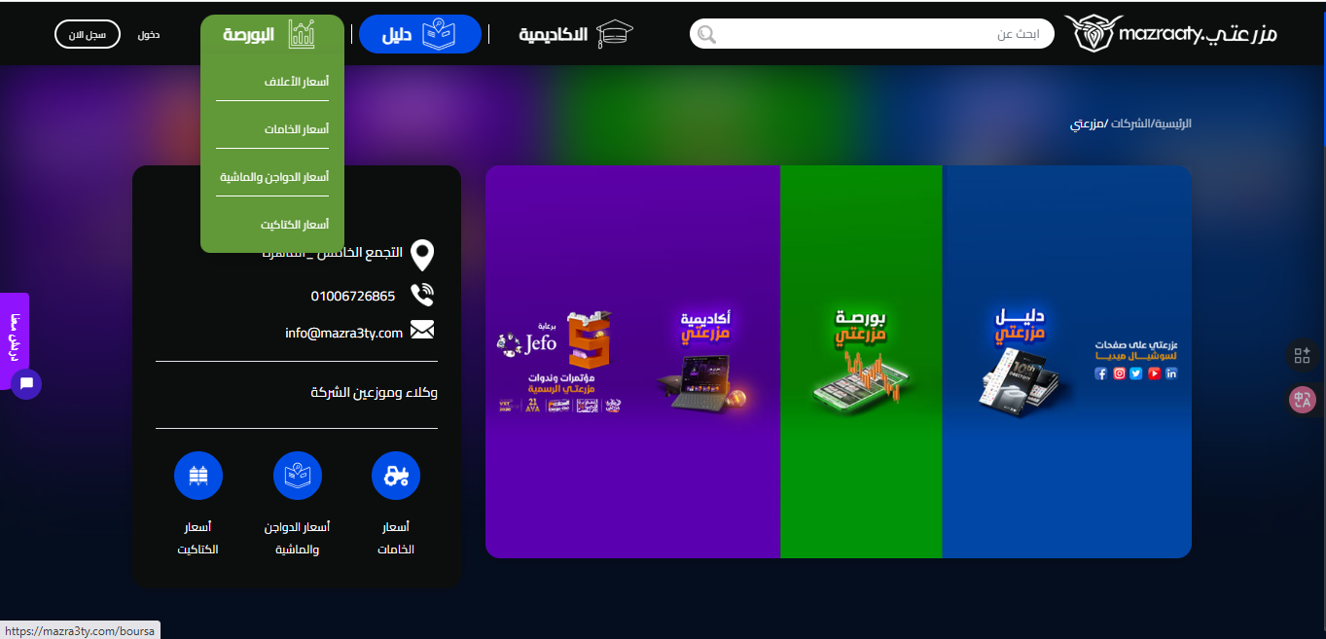

2.2 COMPARISON & LIMITATIONS
2.2.1 Comparative Analysis
The following table provides a comprehensive comparison of existing systems against key features required for a holistic agricultural ecosystem:

Feature/Capability | Investment Platforms | Management Systems | Marketplaces | Arab Platforms | Proposed System
Farmer Investment Access | Limited | ✗ | ✗ | ✗ | ✓
Direct Farmer-Investor Connection | Partial | ✗ | ✗ | ✗ | ✓
AI-Powered Analytics | Basic | Partial | ✗ | ✗ | ✓
Real-Time Project Monitoring | Limited | ✓ | ✗ | ✗ | ✓
Smart Contracts | ✗ | ✗ | ✗ | ✗ | ✓
Direct Market Access | ✗ | Partial | ✓ | Partial | ✓
Transparent Profit Sharing | Partial | ✗ | ✗ | ✗ | ✓
Multi-Stakeholder Platform | ✗ | ✗ | Partial | ✗ | ✓
Arabic Language Support | ✗ | ✗ | ✗ | Partial | ✓
Regional Focus (Arab World) | ✗ | ✗ | ✗ | Limited | ✓
Fractional Investment | ✓ | ✗ | ✗ | ✗ | ✓
Integrated Ecosystem | ✗ | ✗ | ✗ | ✗ | ✓
Low Entry Barriers | ✗ | Partial | ✓ | Partial | ✓
Risk Assessment Tools | Basic | Partial | ✗ | ✗ | ✓
Post-Harvest Sales Support | ✗ | ✗ | ✓ | Partial | ✓

2.2.2 Critical Limitations of Existing Solutions
Geographic and Cultural Limitations
- Western-Centric Design: Most advanced platforms (FarmTogether, AcreTrader, FarmLogs) are designed for Western agricultural contexts and regulatory frameworks
- Language Barriers: Minimal Arabic language support across major platforms
- Cultural Misalignment: Investment models don't align with Arab agricultural practices and land ownership structures
- Limited Regional Coverage: Existing Arab platforms have limited geographic reach and scalability
Functional Limitations
- Fragmented Solutions: No single platform integrates investment, management, and marketplace functions
- Limited Farmer Access: Investment platforms often exclude small-scale farmers or require significant minimum investments
- Lack of Transparency: Insufficient real-time monitoring and reporting for investors
- No Smart Automation: Manual processes for contract execution and profit distribution
- Weak AI Integration: Limited use of artificial intelligence for decision support and risk assessment
Accessibility Limitations
- High Entry Costs: Many platforms require substantial minimum investments or subscription fees
- Complex Technology: Sophisticated systems too complex for farmers with limited digital literacy
- Infrastructure Requirements: Heavy reliance on advanced infrastructure (satellite, IoT sensors) not available in all regions
- Accredited Investor Requirements: Some platforms restricted to accredited or institutional investors

Operational Limitations
- Intermediary Models: Many marketplaces act as intermediaries rather than true peer-to-peer platforms
- Limited Post-Investment Support: Minimal support for harvest, sales, and reinvestment cycles
- Weak Verification Systems: Insufficient user verification and project validation mechanisms
- No End-to-End Solution: Farmers must use multiple disconnected platforms for different needs
Trust and Security Limitations
- Limited Fraud Prevention: Weak mechanisms to prevent fraud or misrepresentation
- Opaque Financial Flows: Unclear profit calculation and distribution processes
- No Dispute Resolution: Minimal structured approaches to handling disagreements
- Data Privacy Concerns: Inadequate protection of sensitive agricultural and financial data

2.3 JUSTIFICATION FOR THE PROPOSED SYSTEM
2.3.1 Addressing the Market Gap
The proposed Agricultural Investment and Management Platform addresses critical gaps in the existing ecosystem:
1. Integrated Multi-Stakeholder Approach
Unlike existing solutions that serve single stakeholder groups, our platform creates a complete ecosystem connecting farmers, investors, and buyers. This integration eliminates the need for multiple disconnected tools and creates synergies across the agricultural value chain.
Justification: Farmers need funding (investment system), operational management (management system), and market access (marketplace). No existing platform provides all three, forcing stakeholders to navigate fragmented solutions with inconsistent data and processes.
2. Regional Focus on Arab Agricultural Context
The platform is specifically designed for the Arab world's unique agricultural landscape, including:
- Arabic-first interface and content
- Alignment with Islamic finance principles and regional investment preferences
- Understanding of local crop types, farming practices, and seasonal cycles
- Compliance with regional regulations and agricultural policies
- Cultural sensitivity in stakeholder interactions
Justification: Western-designed platforms fail to address Arab-specific needs, while existing regional platforms lack the technological sophistication and comprehensive feature sets. The Arab agricultural market represents $1 trillion in potential by 2030, requiring purpose-built solutions.

3. AI-Driven Intelligence and Decision Support
Our advanced AI analytics engine goes beyond basic data collection to provide:
- Predictive analytics for crop yields and market prices
- Risk assessment models specific to regional agricultural conditions
- Personalized investment recommendations based on investor preferences and project characteristics
- Automated anomaly detection and early warning systems
- Performance benchmarking against similar projects and historical data
Justification: Existing platforms offer limited AI capabilities, relying primarily on manual analysis. The complexity and variability of agricultural investments demand intelligent automation to reduce risks and improve decision-making quality.
4. Inclusive and Accessible Design
The platform democratizes agricultural investment through:
- Low minimum investment thresholds enabling fractional ownership
- Simple, intuitive interfaces suitable for users with varying digital literacy
- Mobile-responsive design for access in rural areas
- Support for various payment methods popular in the region
- Progressive disclosure of complexity (simple for beginners, powerful for experts)
Justification: Existing investment platforms exclude small investors and smallholder farmers through high barriers to entry. Our inclusive design unlocks the vast potential of micro-investments and small-scale farming.

5. Complete Value Chain Coverage
Our integrated approach covers the entire agricultural cycle:
- Pre-Season: Project planning and investment matching
- During Season: Real-time monitoring and management
- Post-Harvest: Direct market access and sales facilitation
- Settlement: Automated profit calculation and distribution
- Reinvestment: Encouraging continuous participation
Justification: Fragmented solutions create inefficiencies and data gaps. End-to-end coverage ensures seamless transitions between phases and accumulation of valuable longitudinal data.

2.3.2 Competitive Advantages
Our platform offers distinct competitive advantages:
- First-Mover Advantage in Arab Markets: First comprehensive agri-tech platform specifically designed for the Arab world
- Network Effects: Three-sided marketplace creates powerful network effects as each stakeholder group attracts others
- Data Accumulation: Continuous data collection builds valuable datasets for improving AI models and understanding regional agriculture
- Trust Infrastructure: Verification systems and smart contracts create a foundation of trust that's difficult to replicate
- Scalability: Cloud-based architecture and modular design enable rapid expansion across countries and crop types
- Strategic Partnerships: Opportunities to partner with governments, agricultural organizations, and financial institutions

CHAPTER 3

SYSTEM REQUIREMENTS
&

TECHNIQUE
  - SYSTEM REQUIREMENTS
    - FUNCTIONAL REQUIREMENTS
For Management Part :
ID | Functional Requirement | Description
FR1 | User Registration (Shared) | The subsystem shall allow users to register and authenticate using credentials shared across the main system.
FR2 | Support Reservation | The subsystem shall allow users to reserve support services by filling in personal and farm details.
FR3 | Reservation Confirmation | The subsystem shall display confirmation details (reservation ID, date, and assigned support member).
FR4 | Reservation Management | Users can view, modify, or cancel their reservations within the management section.
FR5 | Admin Support Control | Admins can view all support requests and assign them to field teams.
FR6 | Farmer Guide | The subsystem shall display categorized articles and guides to assist beginner farmers.
FR7 | Guide Search | Users can search guides by keyword, topic, or category.
FR8 | Dashboard Overview | Displays a simple dashboard summarizing farm tasks, weather, and reservation status.
FR9 | Task Management | Users can add, update, or remove daily farming tasks.
FR10 | Weather Integration | Displays current weather and forecasts for the user’s farm region.
FR11 | Notifications | Sends notifications about upcoming reservations, weather alerts, and system updates.
FR12 | Expense Tracking (Optional) | Allows users to record expenses and view simple analytics in the dashboard.

For Investment Part :

ID | Functional Requirement | Description (Priority Integrated, Clear & Testable)
FR1 | User Registration | The system must enable farmers and investors to register with personal details, farm information, investment interests, and payment preferences. Registration must be secure and verifiable.
FR2 | User Verification | The system must verify identities of farmers and investors to prevent fraud using secure authentication methods. Verification must be reliable under normal and peak load conditions.
FR3 | Project Submission | Farmers must submit agricultural project proposals including crop type, estimated cost, expected profit, duration, and potential risks using a structured submission form. The system should provide clear guidance to minimize errors.
FR4 | Project Approval | The system must review and approve submitted projects and make them available as "Investable Projects" in the dashboard. Approval processing should be timely and auditable.
FR5 | Project Display | Approved projects must be displayed to investors with full details, images, and expected financial outcomes in a clear and accessible dashboard. Display should load efficiently for multiple users.
FR6 | Investment Management | Investors must be able to fund projects fully or partially, with the system recording agreements and generating smart contracts specifying profit-sharing, responsibilities, and loss allocation. Investment processes should be secure and auditable.
FR7 | Payment Handling | The system must facilitate secure electronic payments or escrow account transfers from investors to farmers with encryption and confirmation tracking. Payment processing should be reliable and timely.
FR8 | Farming Execution Tracking | Farmers should update weekly reports including images, videos, and crop status.
FR9 | Risk Notification | The system must notify investors immediately in case of issues such as crop disease or natural risks. Notifications should be accurate, timely, and traceable.
FR10 | Harvest Reporting | Farmers should submit actual production and profit reports at harvest, which are verified by the system for accuracy. Reporting should be structured and easy to validate.
FR11 | Profit and Loss Distribution | The system must automatically calculate and distribute profits according to contract terms or assign responsibility for losses. Calculations should be auditable and accurate.
FR12 | Performance Evaluation | Upon project completion, the system could allow rating of farmers and investors to improve transparency and credibility. Ratings should be structured and visible to relevant stakeholders.
FR13 | Reinvestment Option | Investors could reinvest profits directly into new projects through the dashboard. The system should facilitate easy selection and confirmation of reinvestment.

For Market Place Part :
ID | Requirement Name | Description
FR1 | Product Listing (Farmer) | The subsystem shall allow farmers to create product listings by adding crop type, quantity, price, quality grade, and product images.
FR2 | Product Management | Farmers can update, edit, or remove their previously listed products from the marketplace.
FR3 | Marketplace Browsing (Buyer) | The subsystem shall allow buyers to browse available agricultural products using filters (crop type, price range, region, availability, etc.).
FR4 | Product Details View | Users shall be able to view full product details including description, images, farmer profile, and farm location.
FR5 | Direct Contact Feature | The subsystem shall enable buyers to directly contact farmers through in-app messaging, mobile number, or WhatsApp link. (Note: The platform does not process payments, delivery, or storage.)
FR6 | Search & Filtering | Users can search for products by name, category, season, or region, and apply advanced filters such as freshness, price, and available stock.
FR7 | Farmer Profile Viewing | Buyers can view farmer profiles before contacting or making any arrangement.
FR8 | Product Reporting (Optional) | Users can report misleading or inappropriate product listings for admin review.
FR9 | Admin Product Moderation | Admins shall be able to review, approve, block, or archive product listings to maintain quality and trust.

    - NON-FUNCTIONAL REQUIREMENTS
Category | Requirement | Description
Performance | System Response | Each operation (such as reservation or loading a guide) should execute within 9 seconds.
Usability | Simple Interface | Designed for farmers with minimal technical knowledge: clear icons and Arabic / English text.
Reliability | Error Recovery | The subsystem should handle input errors gracefully and log failures for review.
Security | Data Protection | Sensitive information such as user identity and contact info must be encrypted.
Scalability | Integration Ready | Should integrate smoothly with the Investment and Store subsystems under the main platform.
Maintainability | Modular Design | Built as a self-contained module that can be maintained independently.
Availability | System Uptime | The subsystem should remain available 98% of the time for uninterrupted access.
Accessibility | Responsive Design | Compatible with both desktop and mobile devices, supporting right-to-left Arabic layout.
Portability | Shared Architecture | Built using the same technologies as other main system components for consistency.

  - TECHNIQUES AND TOOLS


Frontend Development

React.js was used to develop the frontend of the Agri-Pro Platform due to its
component-based architecture and ability to build scalable and responsive user interfaces.
Reusable components were implemented for dashboards, project cards, investment summaries,
and product listings. Role-based rendering was applied to provide customized views for
Farmers, Investors, Buyers, and Admins.


Tailwind CSS was used for styling due to its utility-first approach, enabling rapid UI
development and consistent design across the platform. Responsive layouts were implemented
using predefined breakpoints to support Desktop, Tablet, and Mobile devices.



Vite and npm were used as build and package management tools to ensure fast development,
efficient dependency management, and optimized production builds.


Backend Development


C# with ASP.NET Core was selected for backend development due to its high performance,
security, and scalability. The backend follows a layered architecture separating controllers,
services, and data access.
RESTful APIs were implemented to enable communication between the frontend and backend.
JWT-based authentication and Role-Based Access Control (RBAC) were applied to secure system
access and manage user permissions.

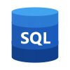

Database and Data Management


Microsoft SQL Server was used as the primary relational database to store structured data
related to users, projects, investments, farms, and marketplace products. Database
transactions and indexing were applied to ensure data consistency and improve performance.
An Analytics Database was used to store reporting and performance metrics, while
Azure Blob Storage was utilized for storing images, reports, and digital contracts.

Security, Infrastructure, and Integrations




Security was ensured using SSL/TLS encryption, JWT authentication, and data
encryption. Infrastructure tools such as load balancing, automated backups, and
monitoring services were implemented to enhance reliability and availability.
External integrations include Weather APIs for agricultural insights and Email/SMS
services for system notifications. Git and GitHub were used for version control,
collaboration, and code backup.

CHAPTER 4

PROPOSED SYSTEM & METHODOLOGY

  - SYSTEM USE CASE DIAGRAM

  - For Management Part :

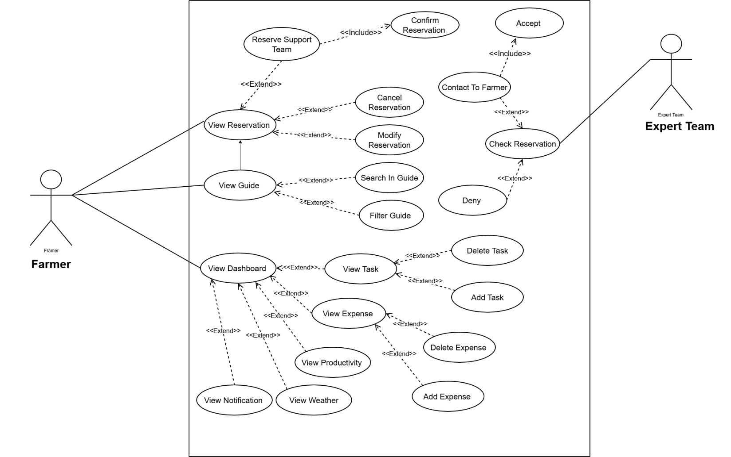

  - For Investment Part:

Farmer & Expert Team:
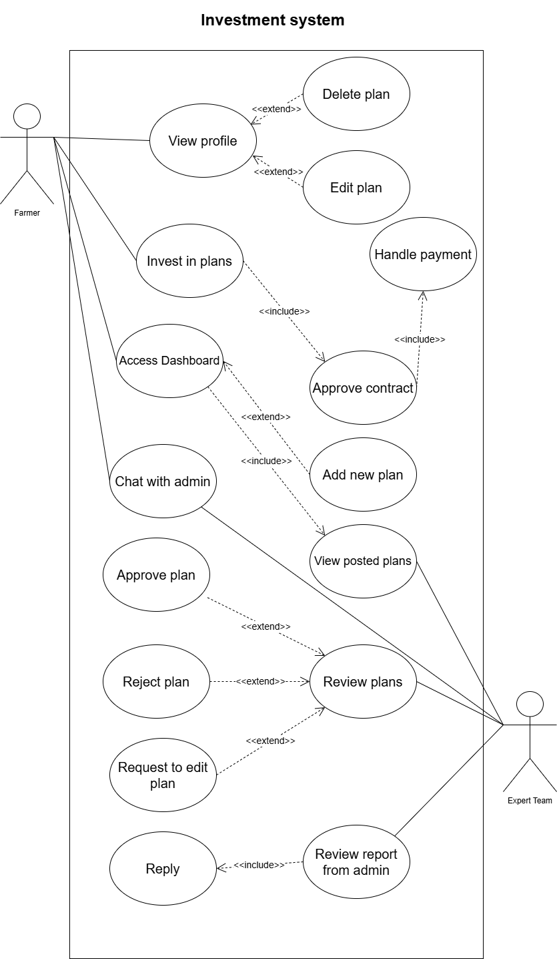

Investor:

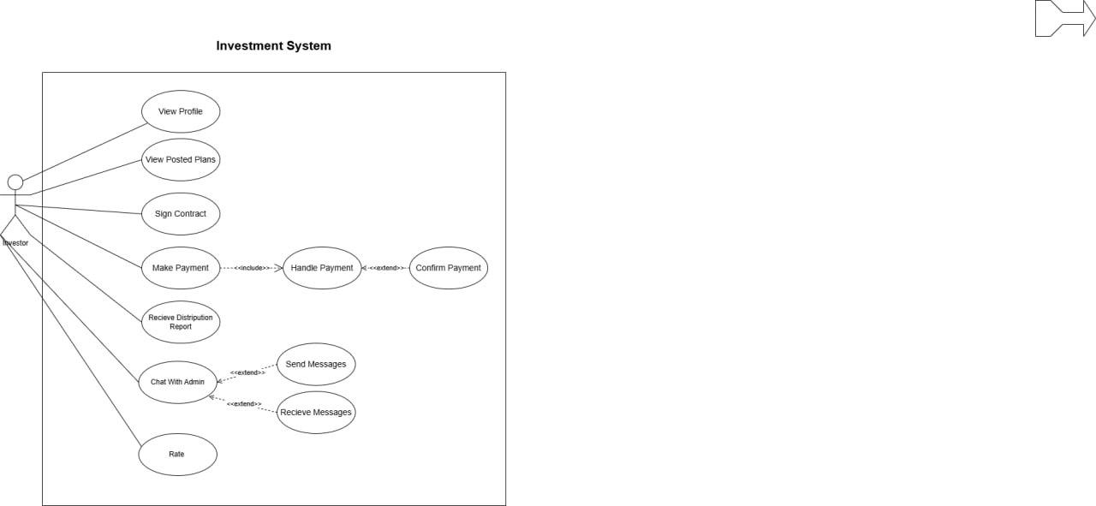

Admin:

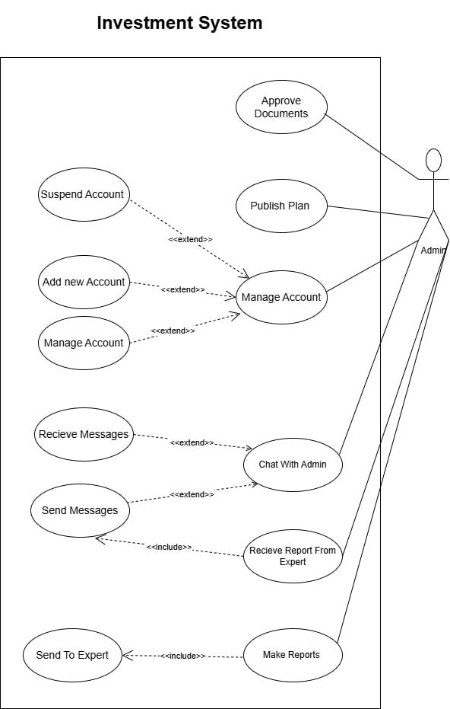

  - For Market Part:

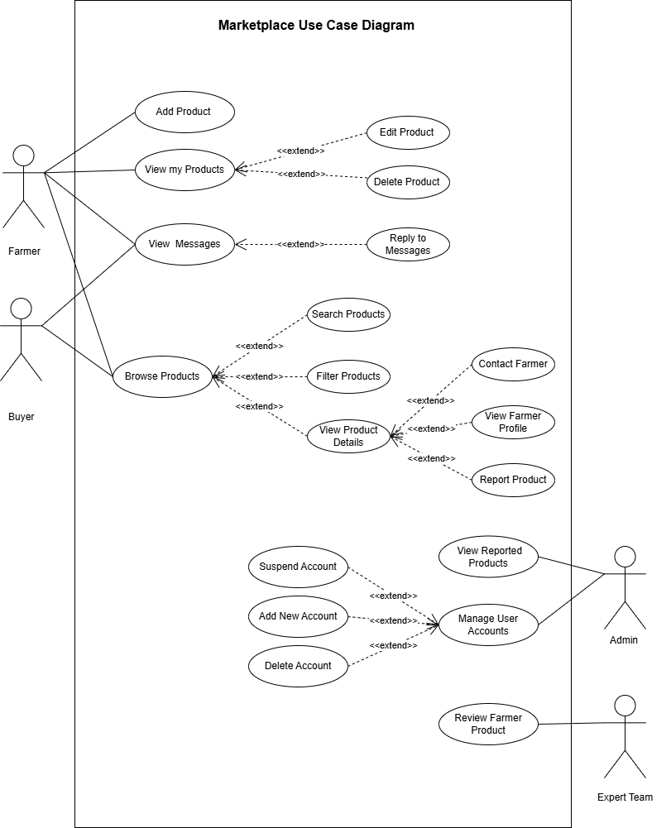

  - USE CASE DESCRIPTION (USE CASE SCENARIO)
For Market Part :
1-Add New Product
Field | Details
Use Case ID | UC-01
Scenario Name | Add Product
Primary Actor | Farmer
Secondary Actors | expert team
Preconditions | • Farmer account is verified.  • Farmer is logged in.  • Access to marketplace module.
Main Flow | 1. Farmer opens “Add Product”.  2. Farmer enters product data: crop type, quantity, price, quality grade, images.  3. Farmer submits the product.  4. System validates data and saves product as Pending Review.  5. Expert team member reviews and approves listing.
Alternative Flow | A1 – Incomplete Data:  System asks for missing fields before submission.  A2 – Draft Mode:  Farmer saves the product as draft and completes it later.
Exception Flow | E1 – File Upload Error:  Image fails to upload; system asks user to retry.  E2 – System Timeout:  Submission interrupted; system restores draft
Postconditions | Successful:  Product listed after approval.  Failure:  Product not created; farmer must reattempt.

2-View My Products:
Field | Details
Use Case ID | UC-02
Scenario Name | view my products.
Primary Actor | Farmer
Secondary Actors | Admin
Preconditions | • Farmer has existing product listings.  • Farmer is logged in.
Main Flow | 1. Farmer opens “View My Products”.  2. System displays all products of the farmer.  3. Farmer chooses a product:  • Edit Product → updates details and saves.  • Delete Product → confirms deletion; system removes product.
Alternative Flow | A1 – Filter Products: Farmer filters products by type or status.
Exception Flow | E1 – Product Under Review:  System blocks editing or deletion and shows a messages.
Postconditions | Successful: Product viewed and updated or deleted)if the farmer made changes).  Failure: No changes made.

3-Messaging Between Farmer and Buyer:
Field | Details
Use Case ID | UC-03
Scenario Name | view messages.
Primary Actor | Farmer / Buyer
Secondary Actors | System
Preconditions | • Both actors are logged in.  • Messaging module is active
Main Flow | 1. Actor opens “View Messages”.  2. System displays received messages.  3. Actor selects a message and replies.  4. System sends the message to recipient.
Alternative Flow | A1 – Search Messages:  Actor searches messages by sender, product, or date.
Exception Flow | E1 – Message Failed:  System notifies sender if message cannot be sent.
Postconditions | Successful:  Message delivered or queued.  Failure:  Message not sent; user can retry.

4-Browse Products:
Field | Details
Use Case ID | UC-04
Scenario Name | Browse Products.
Primary Actor | Buyer / Farmer
Secondary Actors | Farmer, Admin
Preconditions | • Buyer/Farmer is logged in.  • Products exist in marketplace.
Main Flow | 1. Buyer/Farmer opens “Browse Products”.  2. System displays list of available products.  3. Buyer/Farmer optionally uses Search or Filter.  4. Buyer/Farmer selects a product → View Product Details.  5. From product details:  • Contact Farmer.  • View Farmer Profile.  • Report Product.
Alternative Flow | A1 – Multiple Filters:  Buyer/Farmer applies multiple filters to narrow search.
Exception Flow | E1 – No Matching Products:  System shows “No products found”.  E2 – Farmer Unavailable:  System notifies buyer/farmer.  E3 – Reported Product:  Admin notified for review.
Postconditions | Successful:  Buyer/Farmer explores products and can contact farmer or report.  Failure:  Buyer/Farmer cannot proceed due to unavailable products.

5-Review Reported Products:
Field | Details
Use Case ID | UC-05
Scenario Name | Review Reported Products
Primary Actor | Admin
Secondary Actors | Farmer / Buyer
Preconditions | • Product has been reported.  • Admin is logged in.
Main Flow | 1. Admin opens “View Reported Products”.  2. System displays reported products.  3. Admin reviews each product and chooses: Approve, Block, or Archive.
Alternative Flow | A1 – Filter Reports:  Admin filters reports by product type, farmer, or date.
Exception Flow | E1 – Product Deleted:  System removes report automatically if product no longer exists.
Postconditions | Successful:  Reported products handled and listings updated.  Failure:  Report remains unresolved if issue occurs.

6-Manage User Accounts:
Field | Details
Use Case ID | UC-06
Scenario Name | Manage User Accounts
Primary Actor | Admin
Secondary Actors | Farmer / Buyer / Expert team member
Preconditions | • Users exist in the system.  • Reported products exist (if any).  • Admin is logged in.
Main Flow | 1. Admin opens “Manage User Accounts”.  2. System displays list of users.  3. Admin views a user profile.  4. Admin activates, deactivates, or removes accounts.  5. Admin selects “View Reported Products”.  6. System displays list of reported products with reasons.  7. Admin reviews the product and takes action (approve, remove, warn user).
Alternative Flow | 1-Search Users:  Admin searches by name, role, or status.  2-Search Reported Products:  Admin filters reported items by category, date, or farmer.
Exception Flow | 1-User Not Found:  System shows error message.  2-No Reported Products:  System displays “No reports available.”
Postconditions | Successful:  User accounts and reported products updated properly.  Failure:  No changes saved if errors occur.

7-Review farmer products:
Field | Details
Use Case ID | UC-07
Scenario Name | Review Farmer Product.
Primary Actor | Expert Team
Secondary Actors | System
Preconditions | • Expert team member is logged in.  • Farmer has submitted a product listing.  • Product status is “Pending Review”.
Main Flow | 1. Expert opens the “Review Farmer Products” page.  2. System displays the list of pending products.  3. Expert selects a product to review.  4. System displays full product details (name, description, price, images, quantity, crop type).  5. Expert reviews the product information.  6. Expert chooses one of the actions: Approve / Reject / Request Modification.  7. System saves the review decision.  8. System notifies the farmer of the decision.
Alternative Flow | 1- Request Modification:  • Expert selects “Request Modification”.  • System opens a note form for required changes.  • Expert writes modification notes and submits.  • System updates product status to “Needs Modification”.  • Farmer is notified to update the product.  2- Rejection:  • Expert selects “Reject”.  • Expert enters rejection reason.  • System saves decision and notifies the farmer.  3- No Products Available:  • No products are pending review.  • System shows message: “No products available for review.”
Exception Flow | 1-System Error:  • System fails to load product data; expert is asked to retry.  2-Network Timeout:  • Review submission fails; system restores last unsaved action.
Postconditions | Successful:  • Product status updated (Approved / Rejected / Needs Modification).  • Farmer receives notification.  Failure:  • Review not saved; expert needs to retry.

For Management Part:
1) Farmer Login
Field | Details
Use Case ID | UC-01
Scenario Name | Login
Primary Actor | Farmer
Secondary Actors | system
Preconditions | • Farmer has an existing account.  • System is online.
Main Flow | 1-Open system.  2-Enter username and password.  3-System verifies credentials.  4-Redirect to Main Page.
Alternative Flow | - Farmer selects “Forget Password” → system sends reset link.  - Farmer selects “Login with Google” → system authenticates externally.
Exception Flow | - Invalid credentials → system shows error message.  - System allows retry
Postconditions | Successful:  • Famer successfully logs in and accesses their account  Failure:  • Invalid Username or Password

2)Farmer Sing In
Field | Details
Use Case ID | UC-02
Scenario Name | Sign in
Primary Actor | Farmer
Secondary Actors | System
Preconditions | - System online.  - Not yet registered and has required information (phone number or email, password , proof of identity).
Main Flow | - Farmer selects “Create Account”.  - Enters profile details.  - System validates input.  - System creates account.  - Redirects to login page.
Alternative Flow | - Farmer uploads optional documents or images.  - Farmer chooses to skip optional fields.
Exception Flow | - Required fields missing → prompt error.  - Account already exists → suggest password reset
Postconditions | Successful:  - New farmer account created.  - Farmer can now login.  Failure:  - Incorrect Email / Password / phone number

3)Farmer Support Team Reservation
Field | Details
Use Case ID | UC-03
Scenario Name | Reserve Support Team
Primary Actor | Farmer
Secondary Actors | Expert team
Preconditions | - Farmer is logged in
Main Flow | - Farmer opens “Reserve Support”.  - Enters farm or support request details.  - System validates input.  - System generates reservation ID.  - Confirms reservation.
Alternative Flow | - Farmer edits details before submission  - Farmer cancels before submission.
Exception Flow | - Network failure → retry.  - Invalid input → system asks to correct.
Postconditions | Successful:  - Reservation created  - Status = Pending.  Failure:  - No Available Support Team

4) View Reservation
Field | Details
Use Case ID | UC-04
Scenario Name | View reservation
Primary Actor | Farmer
Secondary Actors | System
Preconditions | - Reservation exists.
Main Flow | - Farmer opens “My Reservations”.  - System fetches reservation(s).  - System displays reservation info.
Alternative Flow | - Farmer filters reservations by date or status.
Exception Flow | - No reservations found → display “No Reservations” message.  - Network error → retry.
Postconditions | Successful:  - Reservation details displayed.  Failure:  - There is no reservation

5) Modify Reservation
Field | Details
Use Case ID | UC-05
Scenario Name | Modify reservation
Primary Actor | Farmer
Secondary Actors | System
Preconditions | - Reservation exists  - Reservation is editable (Pending or Waiting Approval)
Main Flow | - Farmer selects reservation.  - Clicks “Modify”.  - Edits details.  - Submits changes.  - System validates and saves.  - System confirms update.
Alternative Flow | - Farmer cancels modification → returns to reservation page.
Exception Flow | - Reservation locked → display message.  - Network error → retry.
Postconditions | Successful:  - Reservation updated  - Status remains Pending or Waiting Approval.  Failure:  - There is no reservation

6) Cancel Reservation
Field | Details
Use Case ID | UC-06
Scenario Name | Cancel reservation
Primary Actor | Farmer
Secondary Actors | System
Preconditions | - Farmer is logged in.  - Reservation exists.  - Reservation is in cancelable state (Pending / Confirmed).
Main Flow | - Farmer opens “My Reservations”.  - Farmer selects reservation to cancel.  - Farmer clicks “Cancel”.  - System asks for confirmation.  - Farmer confirms.  - System updates reservation status to Cancelled.
Alternative Flow | - Farmer declines → Cancellation stops.
Exception Flow | - Server error → System displays retry message
Postconditions | Successful:  - Reservation cancelled- Status updated to “Cancelled”.  Failure:  - There is no reservation

7) View Guide
Field | Details
Use Case ID | UC-07
Scenario Name | View guide
Primary Actor | Farmer
Secondary Actors | System
Preconditions | - Guides available.
Main Flow | - Farmer opens “Guides”.  - System displays categories.  - Farmer selects category.  - System displays guide list.  - Farmer views guide.
Alternative Flow | - Farmer searches within category.
Exception Flow | - No guides found → display message.
Postconditions | Successful:  - Guides displayed.  Failure:  - Network Timeout

8) Search Guide
Field | Details
Use Case ID | UC-08
Scenario Name | search guide
Primary Actor | Farmer
Secondary Actors | System
Preconditions | - Guides database accessible
Main Flow | - Enter search term.  - System filters.  - Display results.  - Farmer selects guide to view
Alternative Flow | - Filter by category  - Farmer sorts results
Exception Flow | - No results found→ display message
Postconditions | Successful:  - Search results displayed.  Failure:  - No Results Found  - Empty Input
9) View Dashboard
Field | Details
Use Case ID | UC-09
Scenario Name | View dashboard
Primary Actor | Farmer
Secondary Actors | System
Preconditions | - Farmer logged in
Main Flow | - Open dashboard  - System loads all modules
Exception Flow | - One module fails → partial load
Postconditions | Successful:  - Dashboard displayed  Failure:  - Database Connection Failure
10) View Task
Field | Details
Use Case ID | UC-10
Scenario Name | View task
Primary Actor | Farmer
Secondary Actors | System
Preconditions | - Tasks exist
Main Flow | - Open task page  - System displays tasks
Exception Flow | - No tasks
Postconditions | Successful:  - Tasks displayed  Failure:  - There are no available tasks
11) Add Task
Field | Details
Use Case ID | UC-11
Scenario Name | Add task
Primary Actor | Farmer
Secondary Actors | System
Preconditions | —
Main Flow | - Select “Add Task”  - Enter details  - System saves
Exception Flow | - Missing fields
Postconditions | Successful:  - Task added  Failure:  - Missing Required Fields

12) Delete Task
Field | Details
Use Case ID | UC-12
Scenario Name | Delete task
Primary Actor | Farmer
Secondary Actors | System
Preconditions | - Task exists
Main Flow | - Select task  - Confirm delete  - System removes task
Exception Flow | - Server error
Postconditions | Successful:  - Task deleted  Failure:  - Tasks remain undeleted
13)View Expense
Field | Details
Use Case ID | UC-13
Scenario Name | View Expense
Primary Actor | Farmer
Secondary Actors | System
Preconditions | - Expense tracking enabled
Main Flow | - Open expense page  - Display expenses
Exception Flow | - No expenses found
Postconditions | Successful:  - Expense shown  Failure:  - Farmer cannot view expense

14) Add Expense
Field | Details
Use Case ID | UC-14
Scenario Name | Add Expense
Primary Actor | Farmer
Secondary Actors | System
Preconditions | —
Main Flow | - Select add expense  - Enter amount/type  - System saves
Exception Flow | - Invalid amount
Postconditions | Successful:  - Expense added  Failure:  - Expense has not been added
15) Delete Expense
Field | Details
Use Case ID | UC-15
Scenario Name | Delete Expense
Primary Actor | Farmer
Secondary Actors | System
Preconditions | - Expense exists
Main Flow | - Select expense  - Confirm deleting  - System deletes
Exception Flow | - Expense Not Found
Postconditions | Successful:  - Expense removed  Failure:  - Expense still undeleted

16) View Weather
Field | Details
Use Case ID | UC-16
Scenario Name | View Weather
Primary Actor | Farmer
Secondary Actors | System
Preconditions | - Weather API available
Main Flow | - Open weather page  - System displays forecast
Exception Flow | - API error
Postconditions | Successful:  - Weather displayed  Failure:  - Farmer cannot view weather
17) View Productivity
Field | Details
Use Case ID | UC-17
Scenario Name | View productivity
Primary Actor | Farmer
Secondary Actors | System
Preconditions | - Productivity data exists
Main Flow | - Open productivity page  - System loads productivity data
Exception Flow | - No data
Postconditions | Successful:  - Productivity displayed  Failure:  - Farmer cannot view productivity

18) View Notifications
Field | Details
Use Case ID | UC-18
Scenario Name | View notification
Primary Actor | Farmer
Secondary Actors | System
Preconditions | - System send notification
Main Flow | - Open notification center  - System displays notifications
Exception Flow | - Network timeout
Postconditions | Successful:  - Notifications shown  Failure:  - Farmer cannot view notification

2) Expert Team Use Case

1) Manage Accounts
Field | Details
Use Case ID | UC-01
Scenario Name | Manage expert profile
Primary Actor | Expert team member
Secondary Actors | System
Preconditions | - Expert is logged in
Main Flow | - Open profile page  - Update profile info  - System validates changes  - System saves updates
Exception Flow | - Invalid data → show error
Postconditions | Successful:  - Expert profile updated  Failure:  - Expert profile has not been updated
2) Login in
Field | Details
Use Case ID | UC-02
Scenario Name | expert login
Primary Actor | Expert team member
Secondary Actors | System
Preconditions | - Expert has a valid account
Main Flow | - Open login page  - Enter username & password  - System validates credentials  - System redirects to dashboard
Exception Flow | - Invalid credentials → display error
Postconditions | Successful:  - Expert member is logged into the system  Failure:  - Expert member cannot login

3) Manage Reservation
Field | Details
Use Case ID | UC-03
Scenario Name | Manage Reservation
Primary Actor | Expert team member
Secondary Actors | System
Preconditions | - Expert logged in & reservation exists
Main Flow | - Open reservation details  - Expert updates status/assigns team  - System saves change  - System confirms update
Exception Flow | - Permission error → show message
Postconditions | Successful:  - Reservation updated  Failure:  - Reservation cannot be managed
4) Contact Farmer
Field | Details
Use Case ID | UC-04
Scenario Name | Contact farmer
Primary Actor | Expert team member
Secondary Actors | System
Preconditions | - Expert logged in & contact info available
Main Flow | - Open reservation  - Click "Contact Farmer"  - System displays communication options  - Expert contacts farmer
Exception Flow | - Missing contact details → show error
Postconditions | Successful:  - Expert contacted the farmer  Failure:  - Expert team cannot communicate with farmer

5) View Reservation
Field | Details
Use Case ID | UC-05
Scenario Name | View reservation
Primary Actor | Expert team member
Secondary Actors | System
Preconditions | - Expert is logged in & there are reservations
Main Flow | - Open reservation list page  - System retrieves all reservations  - System displays reservations with details
Exception Flow | - No reservations found → show “No reservations.”
Postconditions | Successful:  - Reservation list displayed  Failure:  - Expert team cannot see reservation list

For Investment Part:
Farmer:
1 – View Profile
Use Case ID | UC-F01
Use Case Name | View Profile
Primary Actor | Farmer
Secondary Actor | System
Pre-Conditions | Farmer is logged into the system.
Main Flow | 1. Farmer opens profile page.  2. System retrieves personal, farm and account data.  3. System displays profile information.
Alternative Flow | Farmer edits profile data and saves changes.
Exception Flow | System fails to retrieve profile data.
Post-Conditions | Profile information is viewed or updated.

2– Add New Investment Plan
Use Case ID | UC-F02
Use Case Name | Add New Investment Plan
Primary Actor | Farmer
Secondary Actor | Expert Team
Pre-Conditions | Farmer is logged in.
Main Flow | 1. Farmer selects Add New Plan.  2. System displays form.  3. Farmer enters plan details.  4. Farmer submits plan.  5. System validates data.  6. Plan saved as Pending Review.  7. Expert Team notified.
Alternative Flow | System asks farmer to correct invalid or missing data.
Exception Flow | System error while saving plan.
Post-Conditions | Plan stored and awaiting expert review.

3– Edit Plan
Use Case ID | UC-F03
Use Case Name | Edit Plan
Primary Actor | Farmer
Secondary Actor | Expert Team
Pre-Conditions | Farmer logged in and plan exists.
Main Flow | 1. Farmer selects plan.  2. Farmer edits details.  3. System validates updates.  4. System saves changes.
Alternative Flow | Expert Team requests changes after review.
Exception Flow | System update failure.
Post-Conditions | Plan updated successfully.

4– Delete Plan
Use Case ID | UC-F04
Use Case Name | Delete Plan
Primary Actor | Farmer
Secondary Actor | System
Pre-Conditions | Plan not yet approved.
Main Flow | 1. Farmer selects delete plan.  2. System asks confirmation.  3. Farmer confirms.  4. System deletes plan.
Alternative Flow | Farmer cancels deletion.
Exception Flow | Deletion process fails.
Post-Conditions | Plan removed from system.

5– View Posted Plans
Use Case ID | UC-F05
Use Case Name | View Posted Plans
Primary Actor | Farmer
Secondary Actor | Expert Team
Pre-Conditions | Farmer logged in.
Main Flow | 1. Farmer selects View Plans.  2. System displays farmer approved plans.  3. Farmer views plan details.
Alternative Flow | No plans available.
Exception Flow | Plans cannot be loaded.
Post-Conditions | Farmer reviews available plans.

6– Chat with Admin
Use Case ID | UC-F06
Use Case Name | Chat with Admin
Primary Actor | Farmer
Secondary Actor | Admin
Pre-Conditions | Both logged in.
Main Flow | 1. Farmer opens chat.  2. Farmer sends message.  3. Admin replies.  4. Conversation saved.
Alternative Flow | Admin offline, message queued.
Exception Flow | Chat service unavailable.
Post-Conditions | Messages exchanged.

Expert Team

1 – Review Plans
Use Case ID | UC-E01
Use Case Name | Review Plans
Primary Actor | Expert Team
Secondary Actor | Farmer
Pre-Conditions | Pending plans exist.
Main Flow | 1. Expert opens review list.  2. Selects plan.  3. Reviews details.  4. Makes decision.
Alternative Flow | Request edit from farmer.
Exception Flow | Plan data unavailable.
Post-Conditions | Plan status updated.

2 – Approve Plan
Use Case ID | UC-E02
Use Case Name | Approve Plan
Primary Actor | Expert Team
Secondary Actor | Farmer
Pre-Conditions | Plan pending review.
Main Flow | 1. Expert approves plan.  2. System marks as approved.
Alternative Flow | None.
Exception Flow | Approval fails.
Post-Conditions | Plan ready for publishing.

3 – Reject Plan
Use Case ID | UC-E03
Use Case Name | Reject Plan
Primary Actor | Expert Team
Secondary Actor | Farmer
Pre-Conditions | Plan pending.
Main Flow | 1. Expert rejects plan.  2. System updates status.
Alternative Flow | None.
Exception Flow | Rejection fails.
Post-Conditions | Plan rejected.

4 – Reply to Admin Report
Use Case ID | UC-E04
Use Case Name | Reply to Admin Report
Primary Actor | Expert Team
Secondary Actor | Admin
Pre-Conditions | Report received.
Main Flow | 1. Expert reviews report.  2. Sends feedback.  3. System delivers response.
Alternative Flow | Request clarification.
Exception Flow | Message delivery fails.
Post-Conditions | Reply sent.

Admin:

1 – Manage Accounts
Use Case ID | UC-A01
Use Case Name | Manage Accounts
Primary Actor | Admin
Secondary Actor | System
Pre-Conditions | Admin logged in.
Main Flow | 1. Admin views accounts.  2. Admin adds, updates or suspends account.  3. System saves changes.
Alternative Flow | Admin cancels action.
Exception Flow | Saving changes fails.
Post-Conditions | Accounts updated.

2 – Approve Documents
Use Case ID | UC-A02
Use Case Name | Approve Documents
Primary Actor | Admin
Secondary Actor | System
Pre-Conditions | Documents submitted.
Main Flow | 1. Admin reviews documents.  2. Admin approves documents.
Alternative Flow | Reject documents.
Exception Flow | Approval fails.
Post-Conditions | Documents approved.

3 – Publish Plan
Use Case ID | UC-A03
Use Case Name | Publish Plan
Primary Actor | Admin
Secondary Actor | System
Pre-Conditions | Plan approved by experts.
Main Flow | 1. Admin publishes plan.  2. System makes plan visible.
Alternative Flow | Admin delays publishing.
Exception Flow | Publishing fails.
Post-Conditions | Plan published.

4 – Make Reports
Use Case ID | UC-A04
Use Case Name | Make Reports
Primary Actor | Admin
Secondary Actor | Expert Team
Pre-Conditions | Admin logged in.
Main Flow | 1. Admin creates report.  2. System saves report.  3. Admin sends report.
Alternative Flow | Edit report before sending.
Exception Flow | Report save fails.
Post-Conditions | Report sent.

Investor:

1 – Sign Contract
Use Case ID | UC-I01
Use Case Name | Sign Contract
Primary Actor | Investor
Secondary Actor | System
Pre-Conditions | Investor logged in.
Main Flow | 1. Investor reviews contract.  2. Investor signs digitally.  3. System records signature.
Alternative Flow | Investor declines contract.
Exception Flow | Signing fails.
Post-Conditions | Contract signed.

2 – Make Payment
Use Case ID | UC-I02
Use Case Name | Make Payment
Primary Actor | Investor
Secondary Actor | Payment Gateway
Pre-Conditions | Contract signed.
Main Flow | 1. Investor enters payment info.  2. Gateway processes payment.  3. System receives confirmation.
Alternative Flow | Payment rejected.
Exception Flow | Gateway unavailable.
Post-Conditions | Payment completed.

3 – Receive Distribution Report
Use Case ID | UC-I03
Use Case Name | Receive Distribution Report
Primary Actor | Investor
Secondary Actor | Admin
Pre-Conditions | Investment completed.
Main Flow | 1. System sends report.  2. Investor reviews report.
Alternative Flow | None.
Exception Flow | Report unavailable.
Post-Conditions | Report received.

4 – Rate Investment
Use Case ID | UC-I04
Use Case Name | Rate Investment
Primary Actor | Investor
Secondary Actor | System
Pre-Conditions | Investment completed.
Main Flow | 1. Investor submits rating.  2. System saves rating.
Alternative Flow | Investor skips rating.
Exception Flow | Rating save fails.
Post-Conditions | Rating recorded.

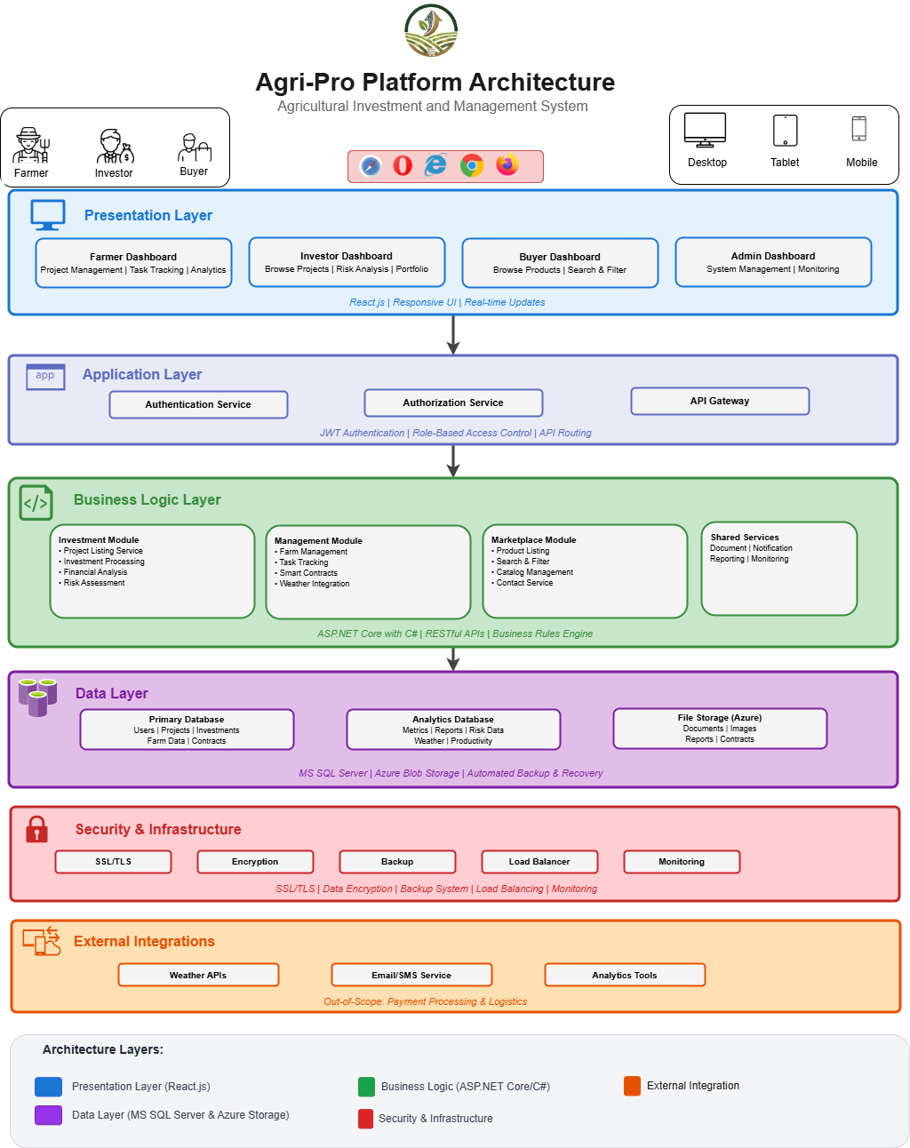
  - SYSTEM ARCHITECTURE

  - DATAFLOW DIAGRAMS

    - CONTEXT DIAGRAM (LEVEL 0)

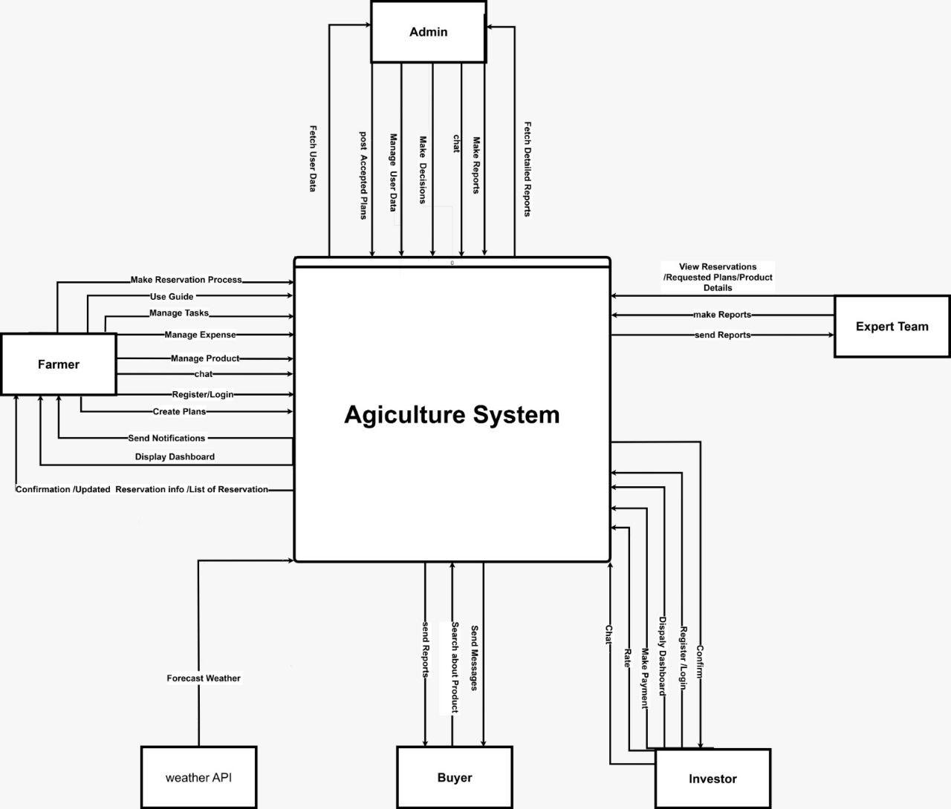

    - DATAFLOW DIAGRAM (LEVEL 1)
Investment:
Logical:
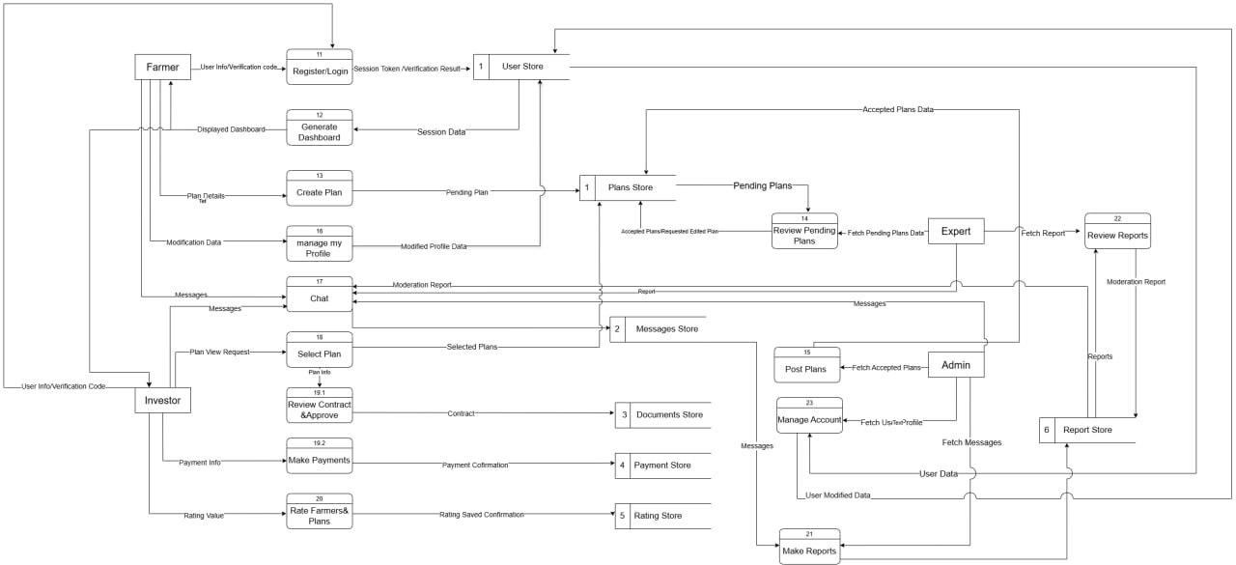

Physical:
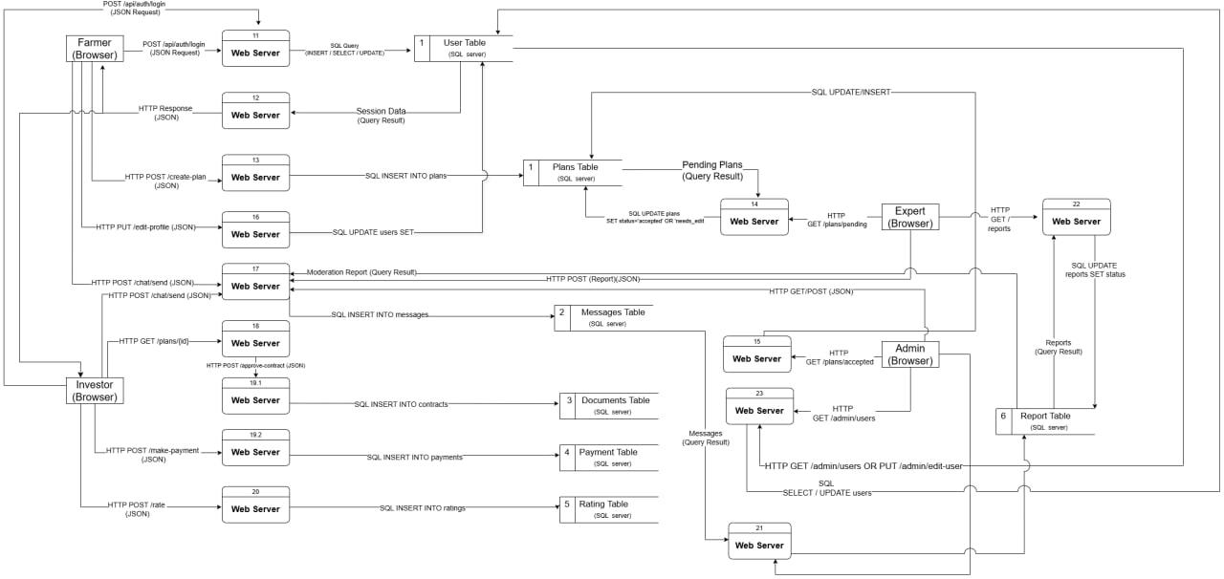
Management:
Logical:
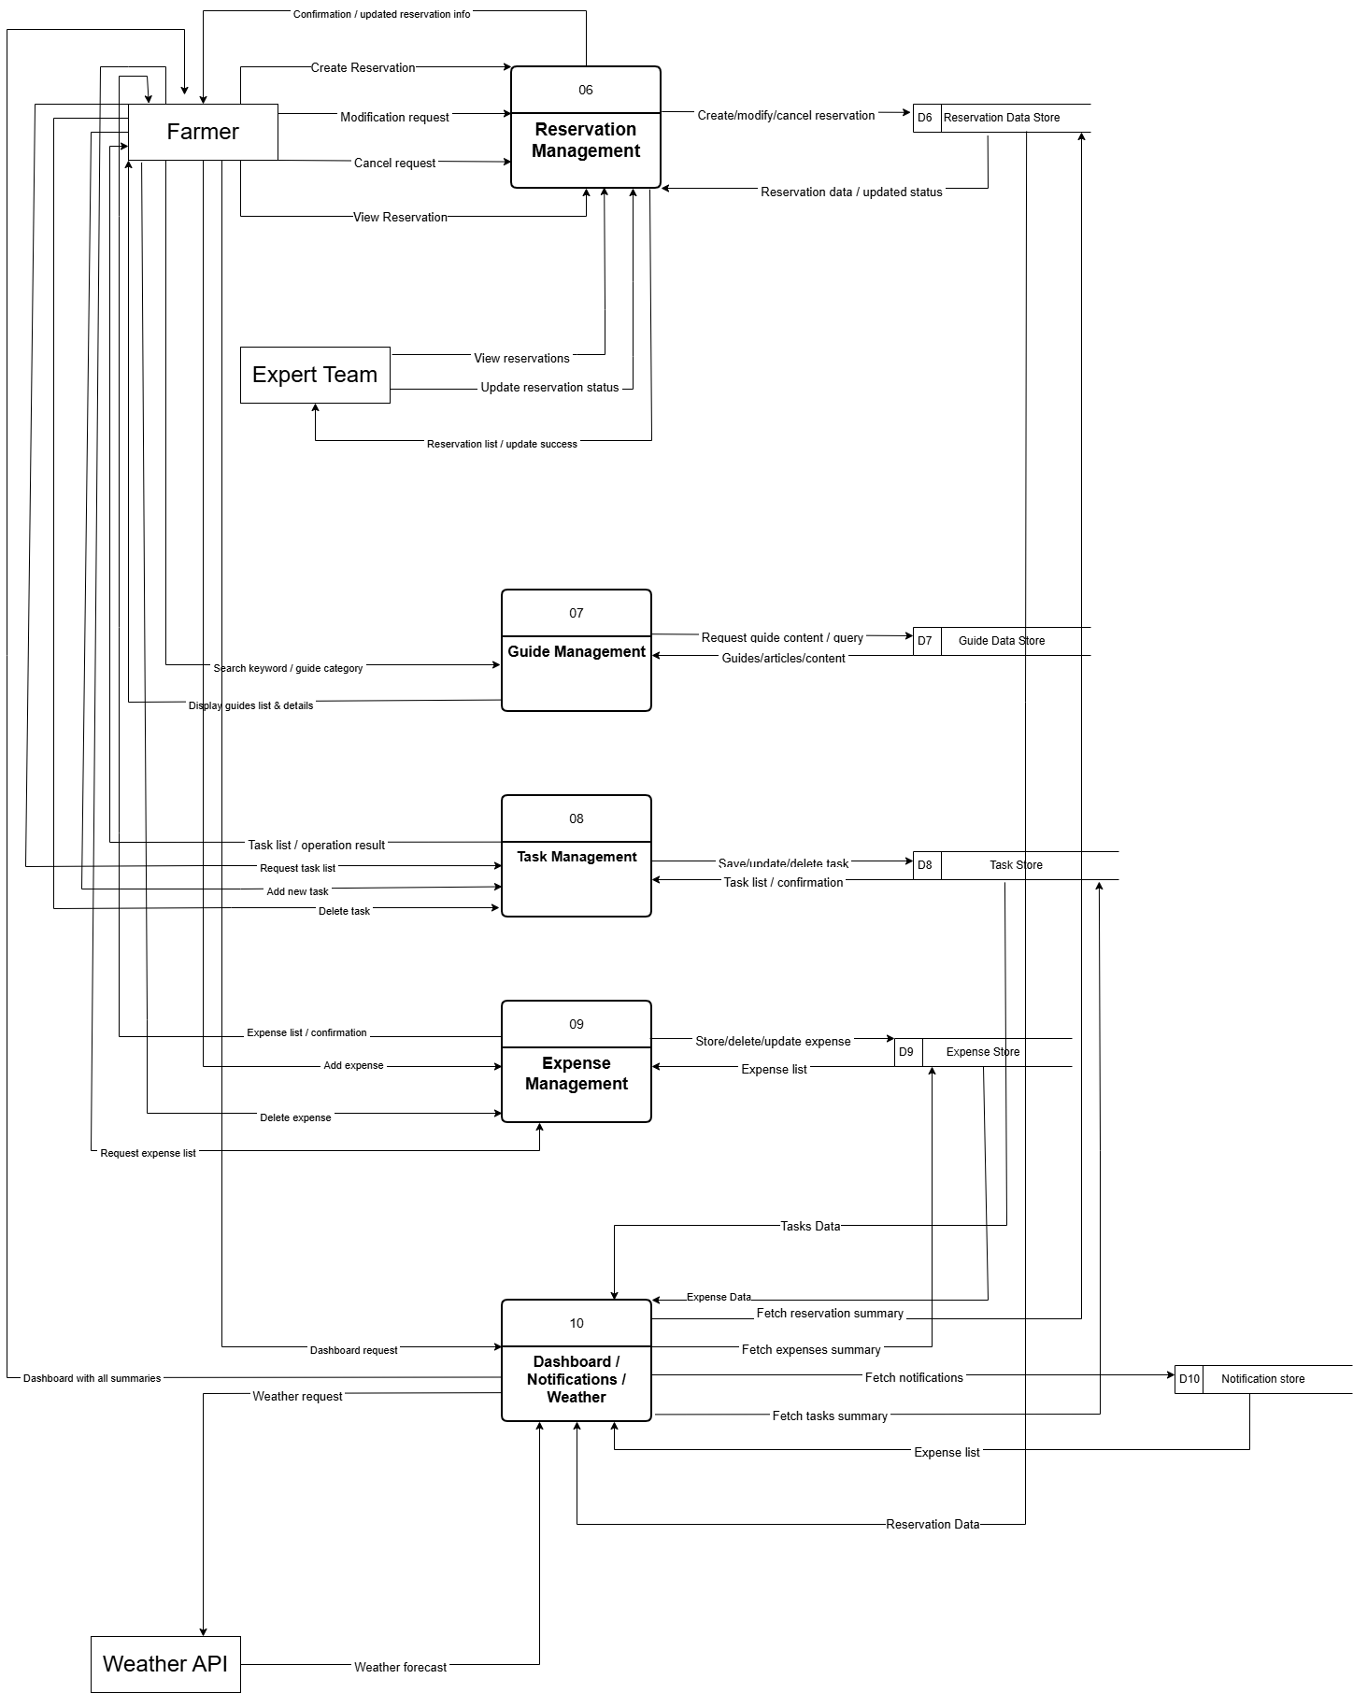

Physical:
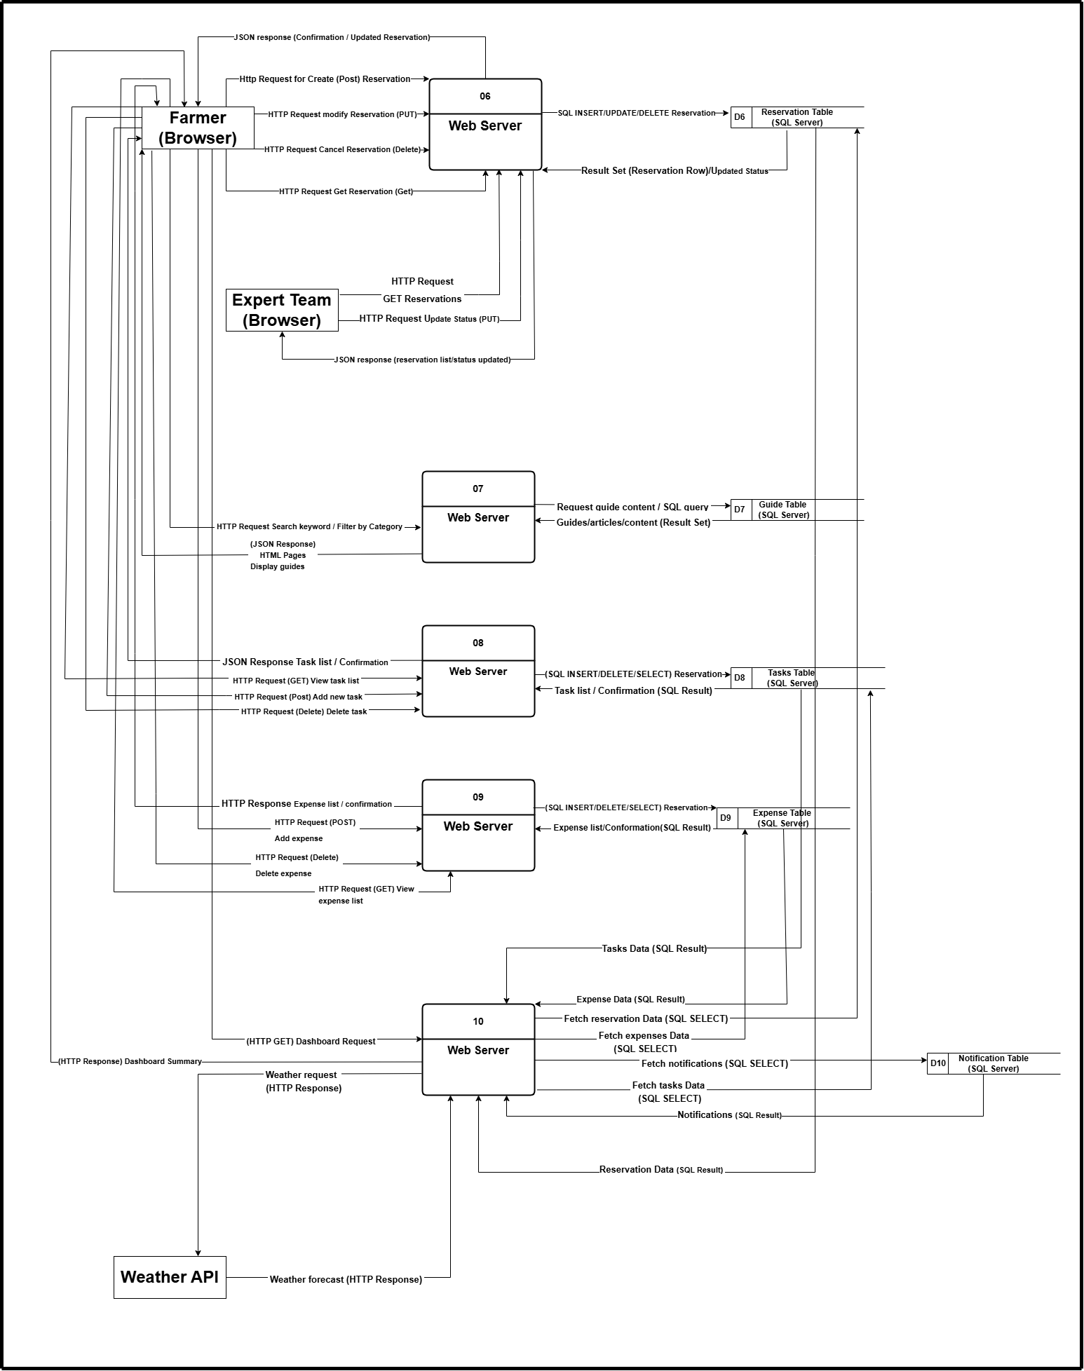

Market:
Logical:
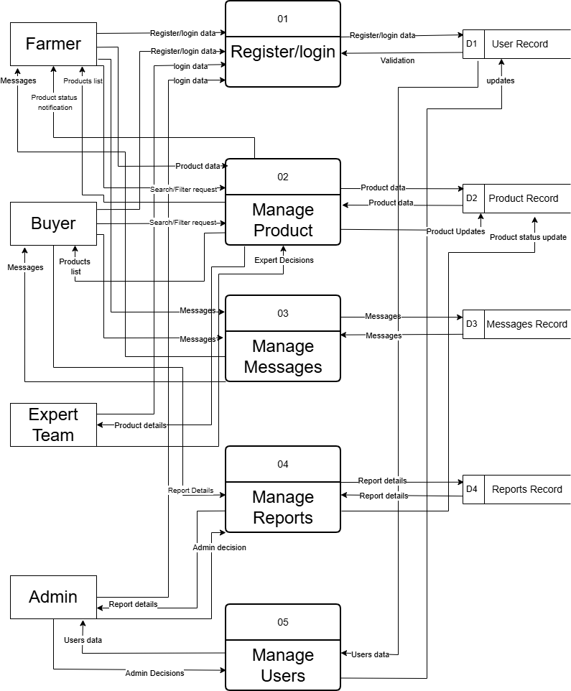
Physical:
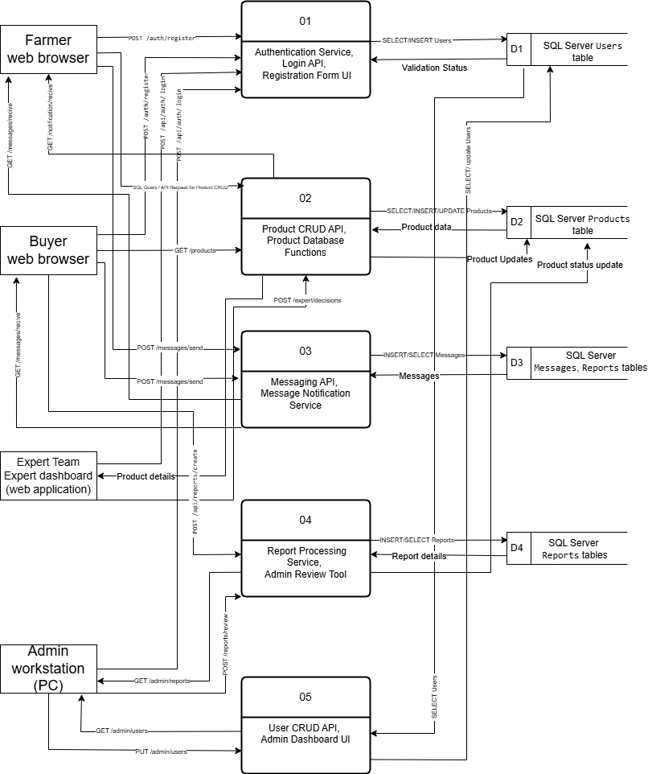

  - ACTIVITY DIAGRAM
Investment:
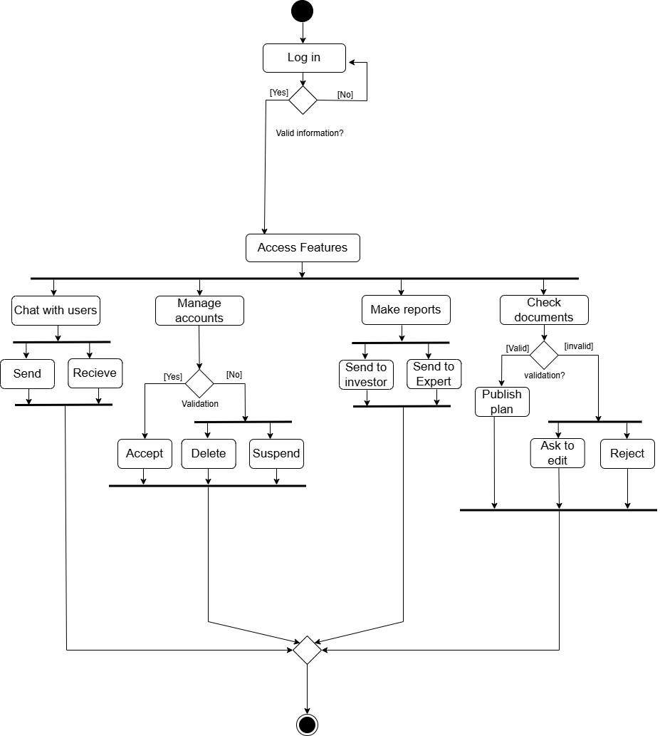
1-Admin

2-Expert Team
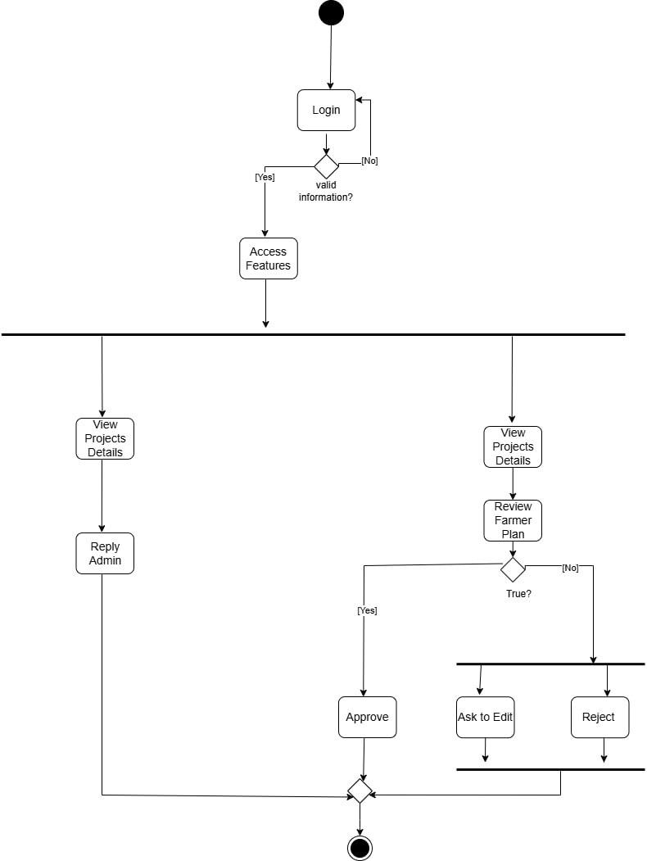

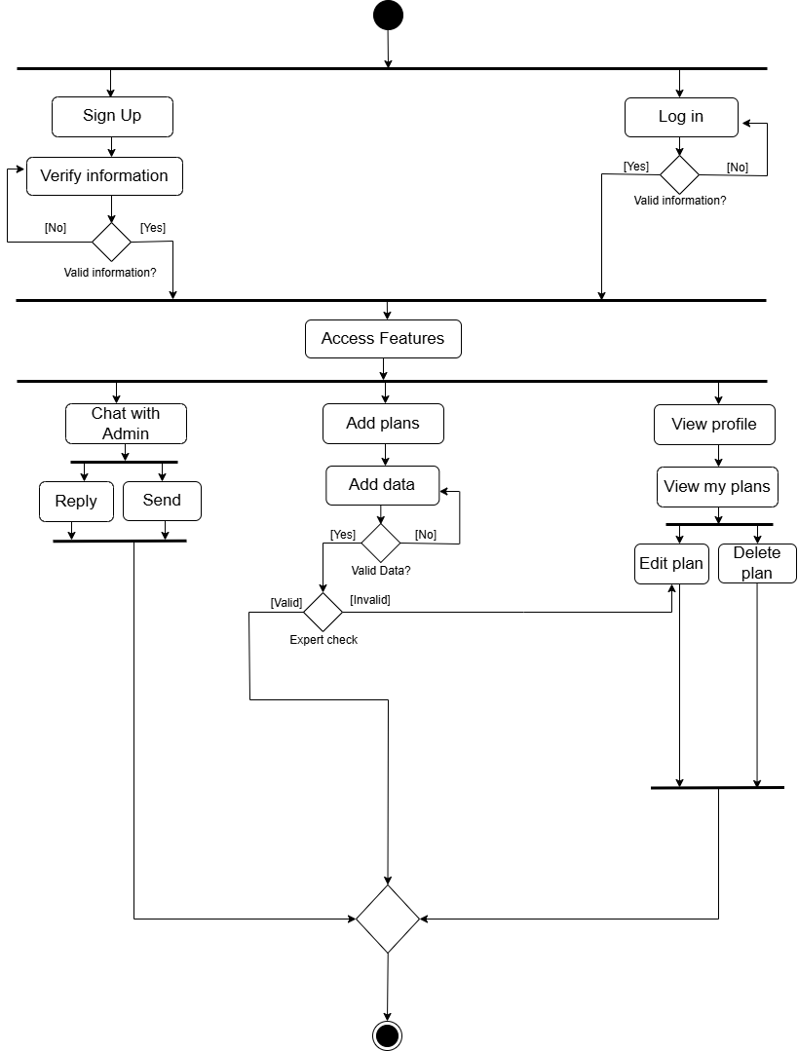
3-Farmer

4-Investor
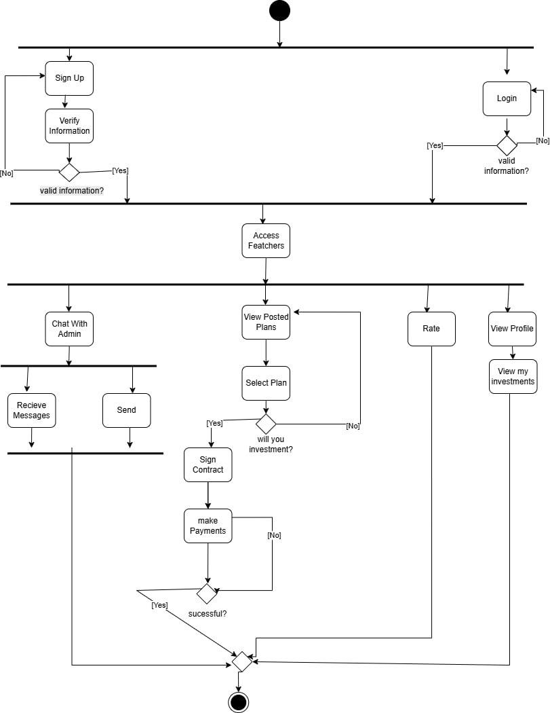

Market:
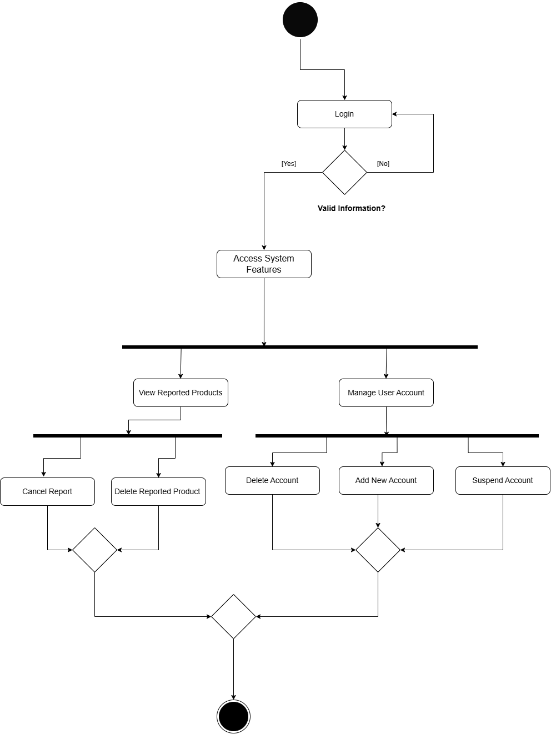
1-Admin

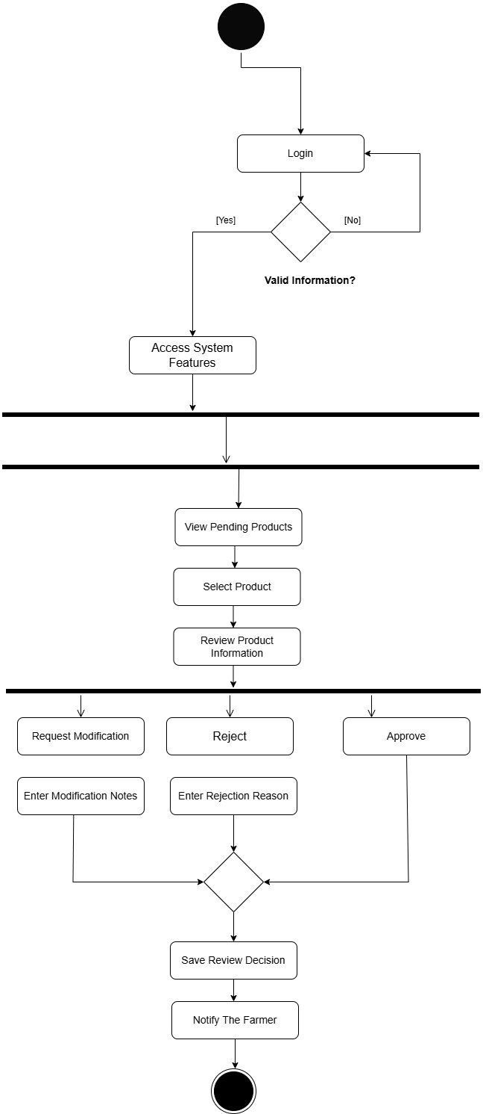
2-Expert Team

3-Farmer

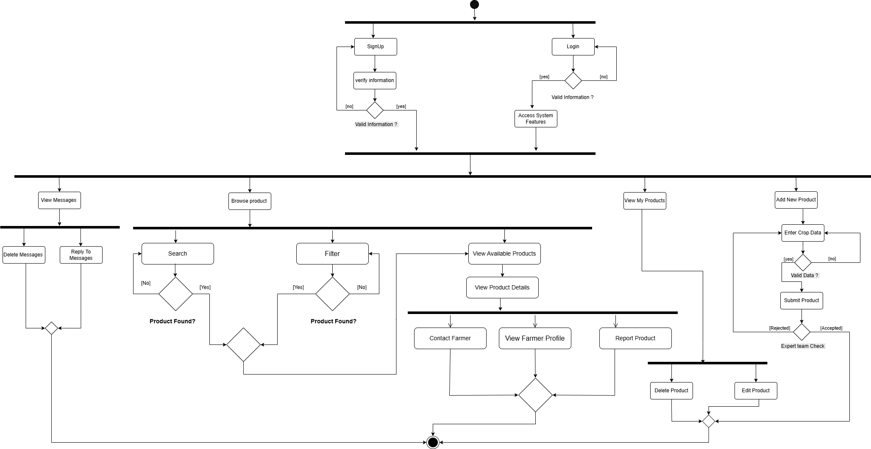

4-Buyer

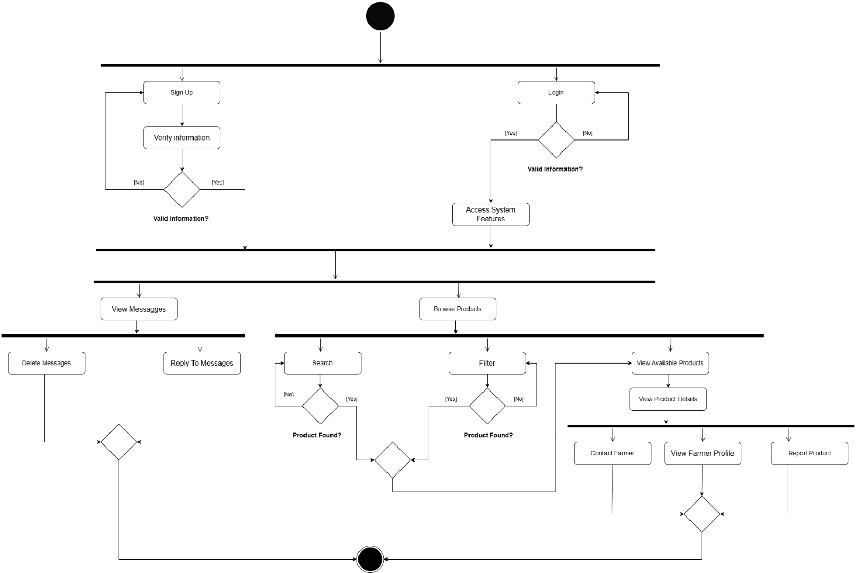

  - ER DIAGRAM

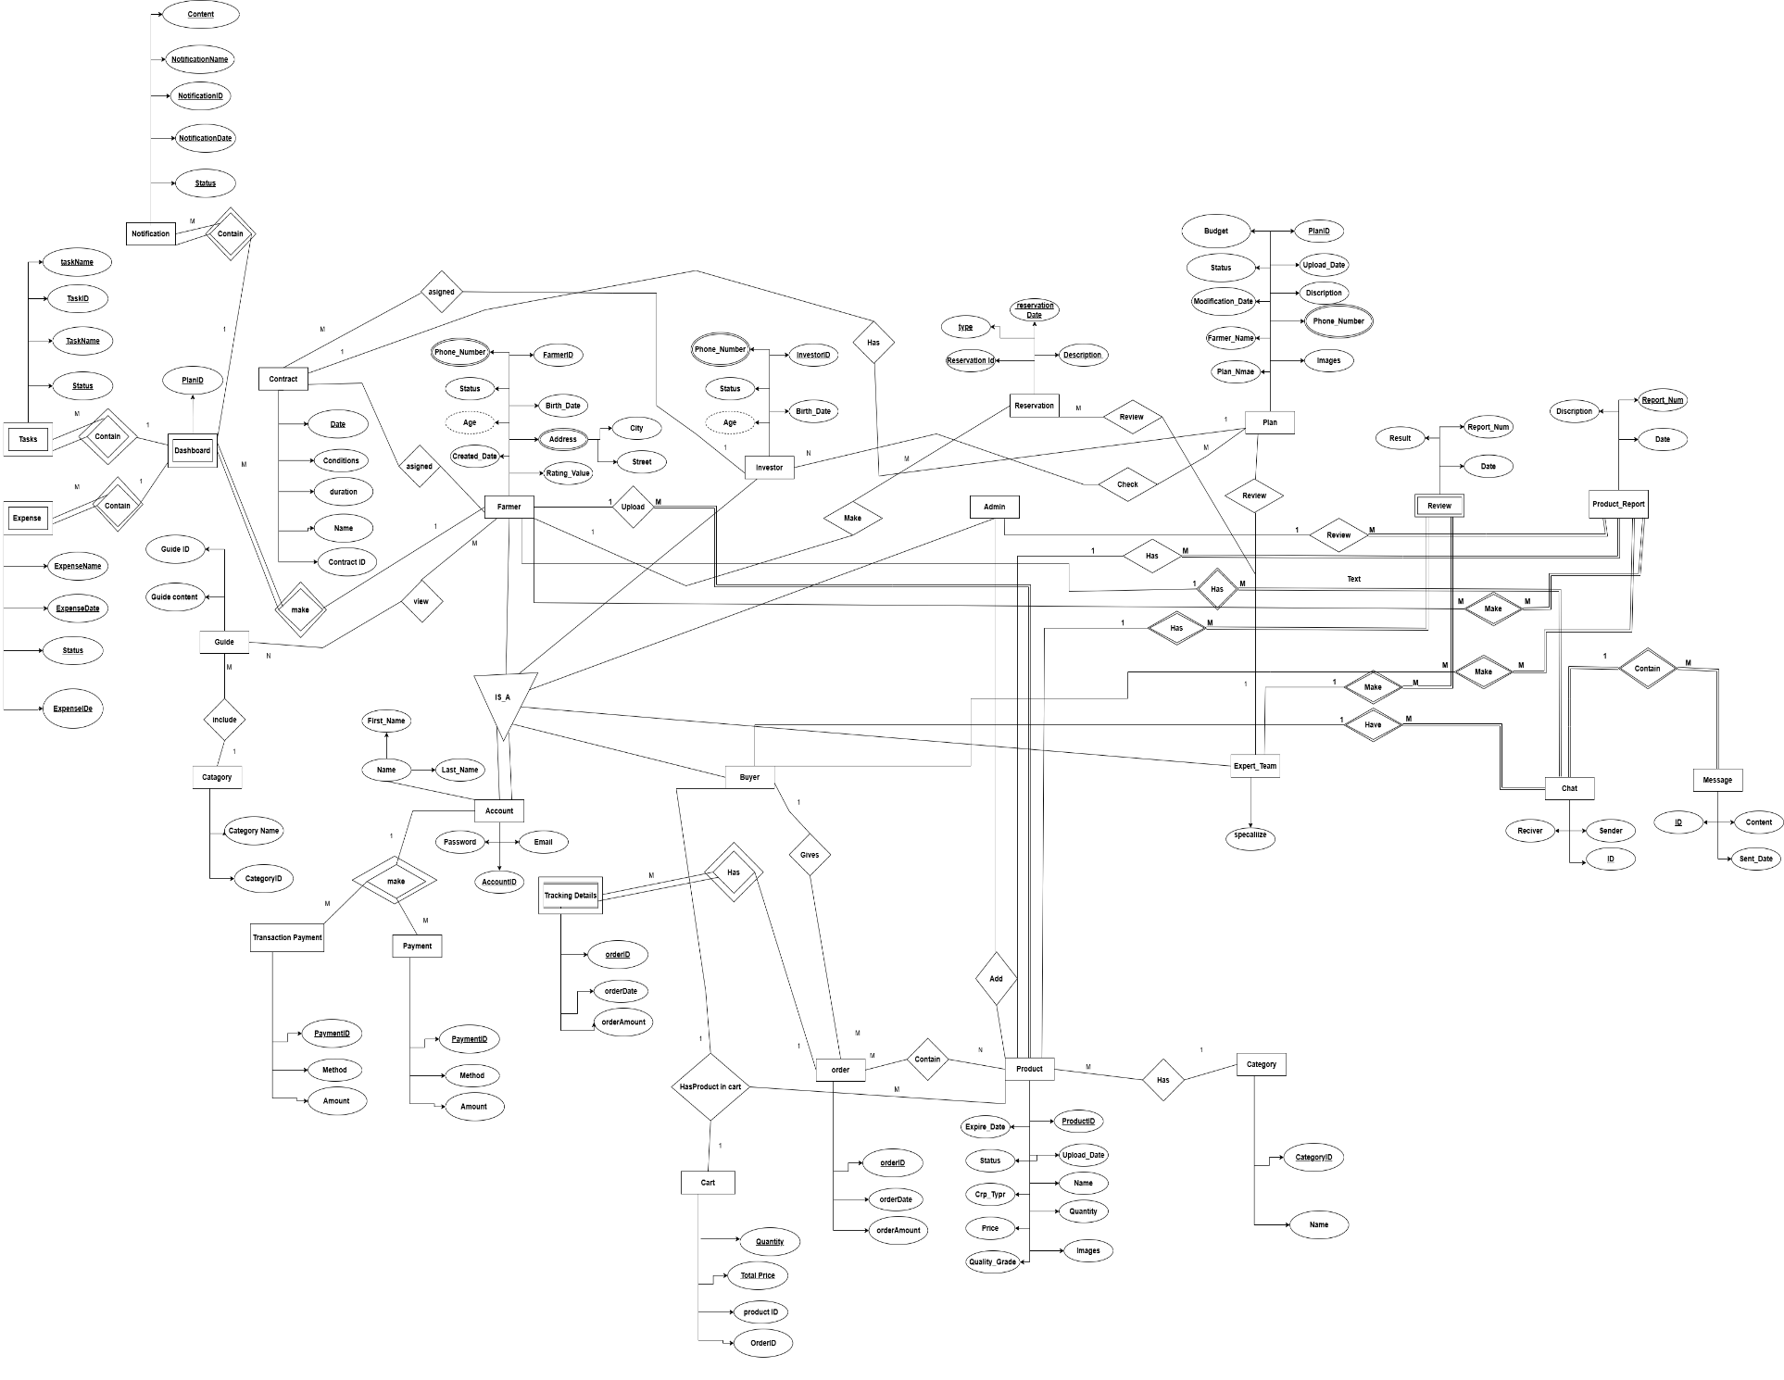

CHAPTER 5

CONCLUSIONS & FUTURE WORK
  - CONCLUSIONS

Agriculture plays a vital role in Egypt’s economy, food security, and employment, yet it continues to face major challenges related to fragmented investment, lack of transparency, limited access to funding, and weak digital management tools. These issues reduce productivity and increase risks for both farmers and investors.

This project presented an Agricultural Investment and Management Platform designed specifically for the Egyptian agricultural sector. The proposed system integrates three main components: an investment system, a farm management system, and an agricultural marketplace. Together, these components create a unified digital environment that connects farmers, investors, and buyers in a structured and transparent manner.

The platform enables farmers to document and manage their agricultural activities professionally, access reliable funding opportunities, and sell their products directly to the market. At the same time, investors gain access to verified project data, real-time monitoring, and clear profit distribution mechanisms, which enhance trust and reduce investment risks. Buyers also benefit from direct access to fresh, locally produced agricultural goods without relying on intermediaries.

Overall, the proposed system supports digital transformation in Egyptian agriculture by improving efficiency, transparency, and decision-making. It contributes to enhancing farmer income, encouraging agricultural investment, and strengthening food security, making it a sustainable and practical solution aligned with Egypt’s agricultural development needs.

  - FUTURE WORK

The following enhancements are proposed as future extensions of the system to improve scalability, intelligence, and overall efficiency:
- Scalability and Performance Optimization
Enhancing system architecture to support a larger number of users and high-volume data processing.
- Advanced Machine Learning Models
Implementing more sophisticated predictive models to improve decision-making accuracy and investment forecasting.
- Offline Mode Support
Allowing limited system functionality in areas with weak or unstable internet connectivity, with data synchronization when the connection is restored.
- User Behavior Analytics
Analyzing user interactions to improve system usability, personalization, and overall experience.
- Advanced Cybersecurity Mechanisms
Implementing stronger encryption, intrusion detection, and fraud prevention techniques to ensure data integrity and platform security.
- Integration with Governmental and Regulatory Systems
Connecting with official databases related to land ownership, agricultural permits, or compliance verification when available.
- Supply Chain Expansion
Extending the system to cover the full agricultural supply chain, from production and storage to distribution and sales.
- Predictive Economic and Risk Analysis
Using historical and real-time data to predict financial risks, market fluctuations, and potential losses.
- Simulation and Scenario Modeling
Allowing users to simulate different investment or production scenarios before making real-world decisions.

- Explainable Artificial Intelligence (XAI)
Providing transparent explanations for AI-generated recommendations to enhance trust and understanding.
- Role-Based Access Control (RBAC)
Defining advanced permission levels for different system users to ensure secure and organized access.
- Geographic Information System (GIS) Integration
Visualizing farms, lands, and investments on interactive maps for better spatial analysis.
- Environmental Impact Assessment Tools
Evaluating sustainability and environmental effects of agricultural activities.
- Business Intelligence and Analytics Dashboards
Offering interactive dashboards with real-time insights and performance indicators.
- Blockchain Integration (Future Consideration)
Enabling secure, transparent, and tamper-proof transaction records.
- Cross-Regional and Multi-Language Expansion
Supporting multiple regions, languages, and regulatory environments.
- Community-Based Recommendation System
Leveraging collective user experiences to improve investment and farming recommendations.

  - REFERENCES

https://www.businesstodayegypt.com/Article/1/5364/Entlaq-Launches-Egypt%E2%80%99s-1st-Agritech-Report

https://www.zawya.com/en/economy/north-africa/african-agribusiness-market-expected-to-reach-1tr-by-2030-ha77kb4y

https://data.worldbank.org/country/egypt-arab-rep

